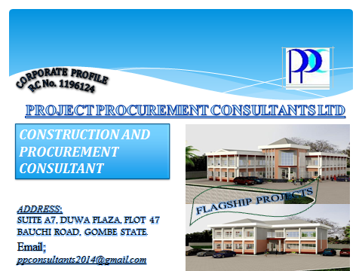

**CONTENTS**

SECTION I **ABOUT THE FIRM**

Introduction

History/Strategic Objective(s)

Services/Strength

SECTION II **REGISTERATION CERTIFICATE(S)**

CAC

Memorandum and Articles of Association

VAT Registeration

Tax Clearance

PENCOM Certificate

ITF Certificate

Evidence of Registeration with Financial Reporting Council

Sworn Affidavit

BPP’s Interim Registeration Report

NSITF Certificate

Evidence of Registeration with Professional Body

Functional Office Address and Contact

SECTION III **PROFILE OF STAFF/STRATEGIC PARTNERS**

Partners

Other Staff

SECTION IV **EVIDENCES OF FIRM’S INVOLVEMENT ON SOME PROJECTS**

Letter of Appointment as Consultants for the Production of Design and Supervision for Needs Assessment Phase II Project.

Letter of Appointment as Consultants for the Construction of Story Complex to Accommodate Lecture Rooms, Laboratoris and Offices.

SECTION V **COMPANY’S AUDITTED ACCOUNT/FINANCIAL CAPABILTY**

2016 Auditted Account

2015 Auditted Account

Letter From Skye Bank

SECTION I **ABOUT THE FIRM**

Introduction

History/Strategic Objective(s)

Services/Strength

**INTRODUCTION**

This brochure is aimed at introducing **PROJECT PROCUREMENT CONSULTANTS LTD;** a Professional Service Firm

**HISTORY/STRATEGIC OBJECTIVE(S)**

**PROJECT PROCUREMENT CONSULTANTS LTD,** was incorporated as a Construction and Procurement Consultancy Firm of the Ninth (9th) day of June, 2014 with registerarion number RC 1196124.

Our objective (is)/are: to be a “one stop shop” on all matters relating to professional services/advice on construction and procument of Goods,Works and Services; and also offer professional training on Project Management and Sustainable Construction/Buildings.

This, we intend to achieve by harnessing on the diverse expertise and experience, networks, and above all creative/innovative abilities of our team and Partners.

Our Founding Directors/Partners, had worked in different sector of Construction Industry, consulting and contracting on both building and civil engineering projects, for close to a decade, before setting up this practice.

We have strategic partnerships/alliances with individual consultants and firms to offer services in our none core area of compentecies.

Within two years of our operation, we have, as Lead Consultants, successfully managed and delivered, Presidential Needs Special Intervention Phase II Projects for Gombe State University (Procument of Teaching & Research Facilities, Construction of Lecture Halls, Offices and Sporting Facilities together with Associated External Works, and Provision of Water/Electrical Services), and also been appointed as Consultants for the construction of Story Complex to Accommodate Lecture Rooms, Laboratories and Offices by Federal College of Horticulture Dandin-Kowa.

Our office is Located at Suite A7, Duwa Plaza, Plot 47 Bauchi Road Gombe. It is fully equipped and computerized, and has up to date Library.

All our staff are conversant with latest softwares in their areas of expertise.

We are truly committed to meeting up/exceeding our clients’/strategic partners expectations and building a legacy practice.

**OUR SERVICES/STRENGTH**

We provide comprehensive in house services on our areas of core compentencies **and collaborate with our partners to offer services on the non core areas – Design & Supervion, Research and Training, Dispute Resolution and other Legal services.** Our core areas of competence include:

* **Contract Documentation;**
* **Cost Management;**
* **Contract/Claims Management;**
* **Project Management;**
* **Procurement Advisory Services.**

Currently, we have six (6) Quantity Surveyors, 1 Architect, 1 Civil/Structural Engineer, a Secretary/Admin officer, as Foundation staff. Also, we are into strategic partnership/alliance with 3 individuals (Part time Consultants); and 2 Architectural Firms, 2 Engineering Services Firm and 1 Law firm.

|  |  |  |
| --- | --- | --- |
| S/N | NAME(S) | QUALIFICATION |
| A | FOUNDATION/INHOUSESTAFF |  |
| 1 | ABUBAKAR HASSAN | B. Tech QS, Msc Const. Mgt,RQS |
| 2 | AHMAD MUHAMMAD KABIR | B. Tech QS,RQS |
| 3 | HASSAN ALI KUMO | B. Tech QS, Msc Const. Mgt. RQS |
| 4 | YUSUF IBRAHIM | B. Tech QS |
| 5 | HARUNA SAIDU | B. Tech QS |
| 6 | KWARGANA IMRAN LAWAL | B.Eng.(Hons)Civil Engineering. |
| 7 | USMAN MUHAMMAD KABIR | B. Tech(Hons) Architecture |
| 8 | IBRAHIM YARO | B.sc Econs, |
| B | INDIVIDUALCONSULTANT(S) |  |
| 9 | EPHRAIM STEPHEN MSHELIA | B.Eng.(Hons)Civil Engineering.MNSE |
| 10 | JOSHUA, Japhet | B.Eng.(Hons)Civil Engineering.MNSE |
| 11 | AUWAL SULEIMAN | B.Eng.(Hons)Civil Engineering.MNSE |
| C | STRATEGIC PARTNERS FIRM |  |
| 12 | MESSRS CAD NIGERIA LTD | ENGINEERIG SERVICES |
| 13 | MESSRS WADO AND ASSOCIATE ENG CONSULT LTD | ENGINEERING SERVICES |
| 14 | MESSRS LAND-BUILDS CONSORTIOUM | ARCHITECTURAL SERVICES |
| 15 | MESSRS MATRIXPROCONZULT | ARCHITECTURAL SERVICES |
| 16 | MESSRS BRAJ ASSOCIATES | LEGAL SERVICES |

The list of Staff/ Strategic Partners is shown below , while their detailed CVs/Profile are in section II.

SECTION II **REGISTERATION CERTIFICATE(S)**

CAC

MEMORANDUM AND ARTICLES OF ASSOCIATION

VAT REGISTERATION

TAX CLEARANCE

PENCOM CERTIFICATE

ITF CERTIFICATE

EVIDENCE OF REGISTERATION WITH FINANCIAL REPORTING COUNCIL

SWORN AFFIDAVIT

BPP’S INTERIM REGISTERATION REPORT

NSITF CERTIFICATE

EVIDENCE OF REGISTERATION WITH PROFESSIONAL BODY

FUNCTIONAL OFFICE ADDRESS AND CONTACT



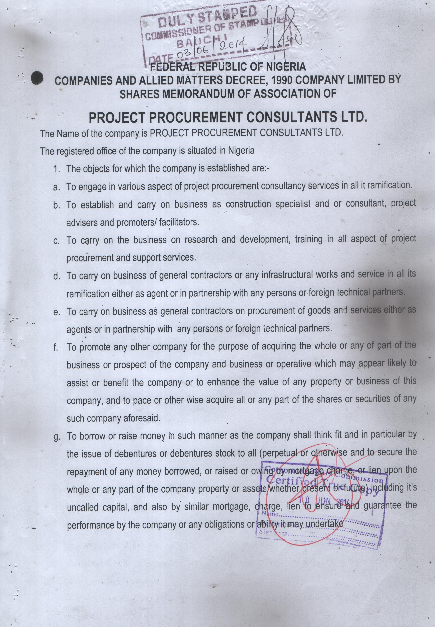

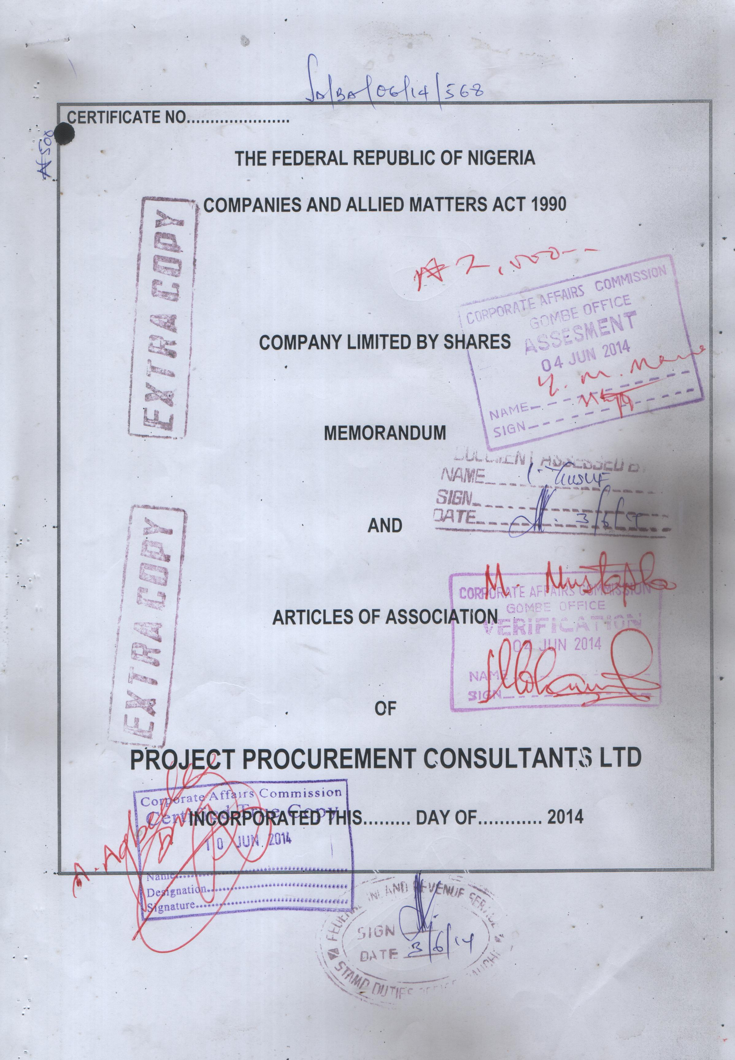

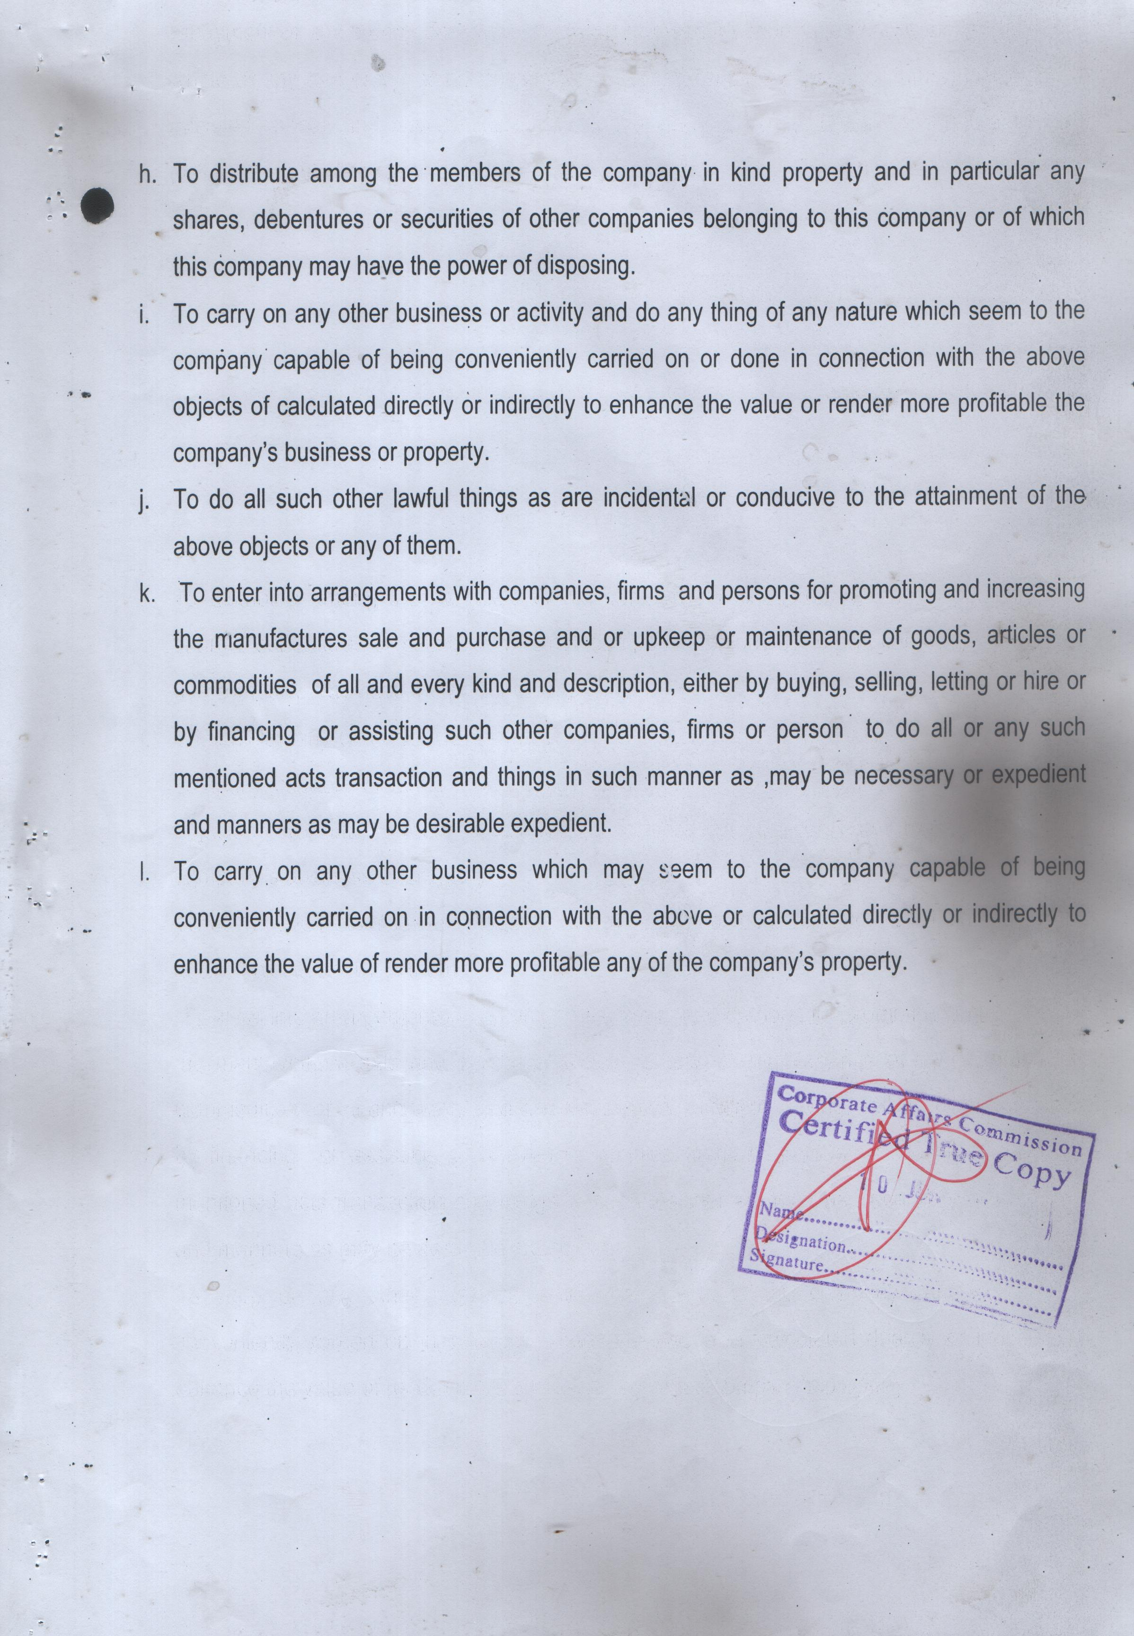

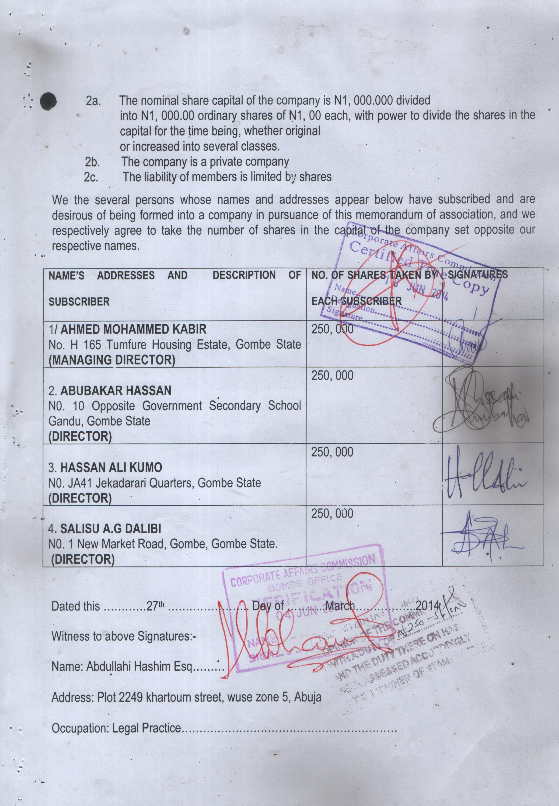

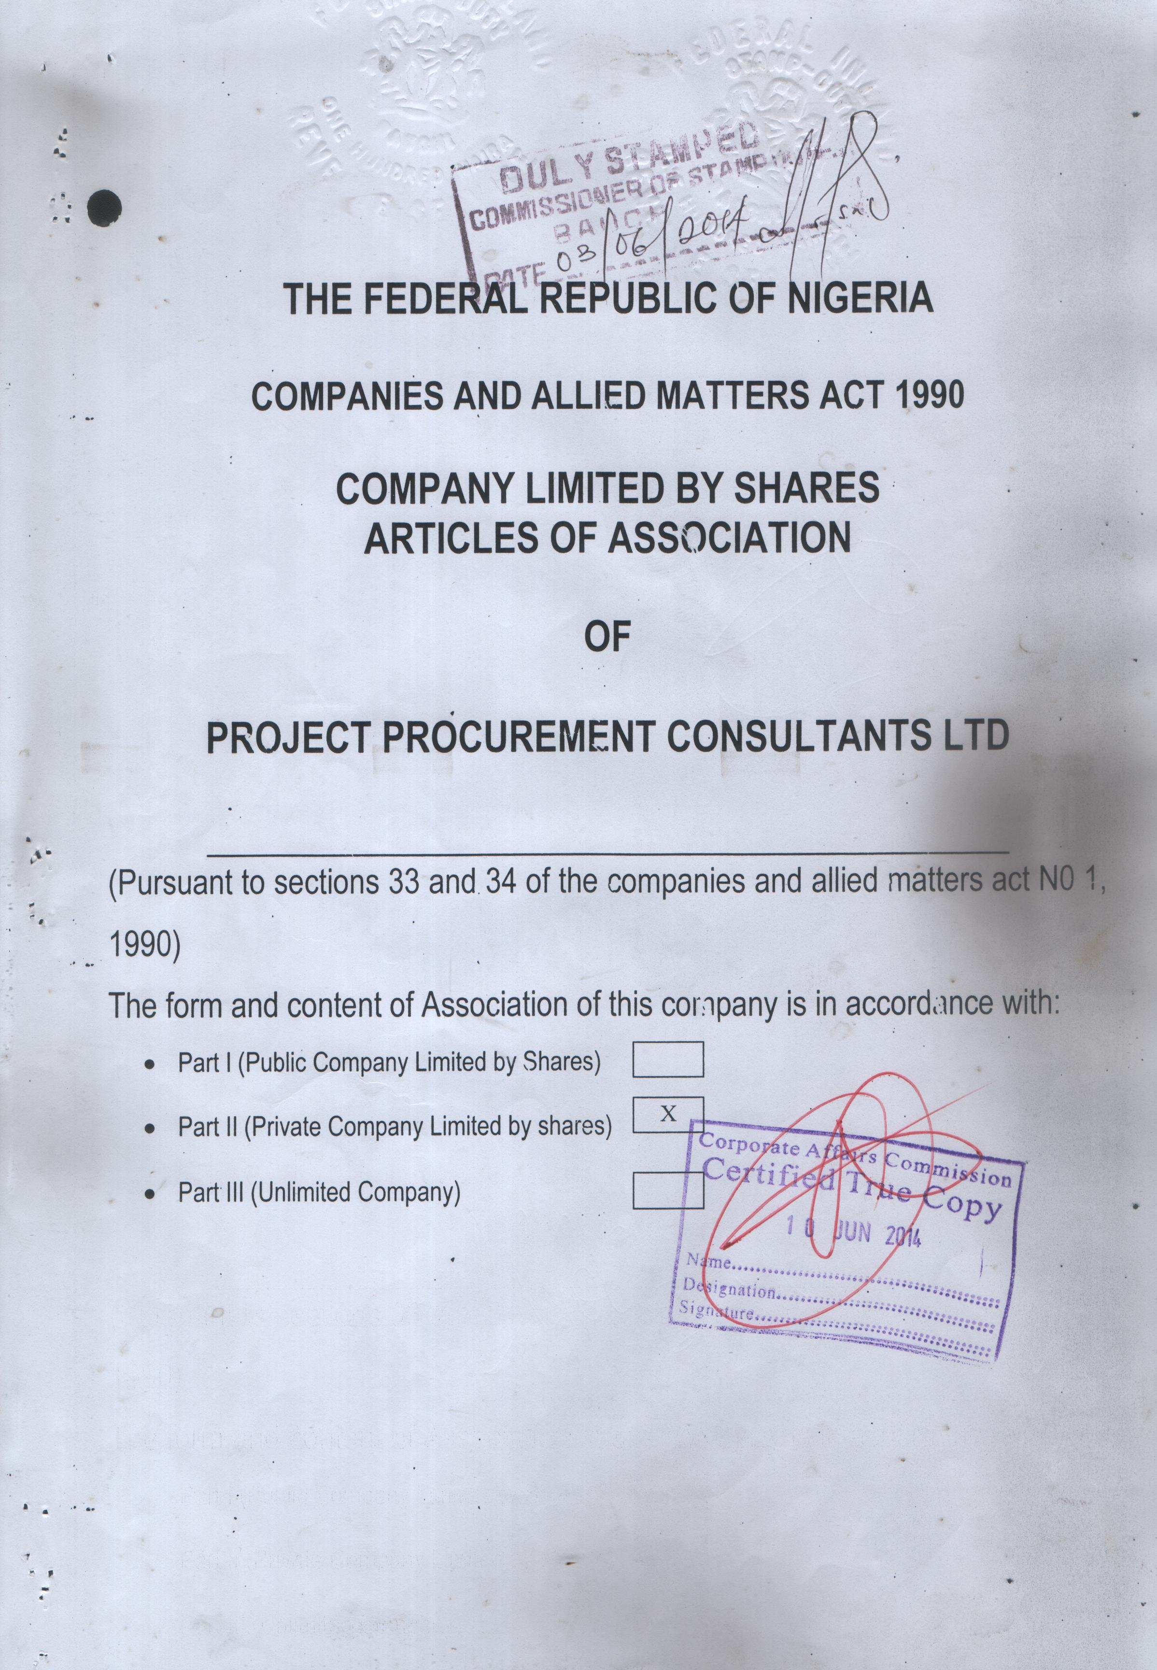

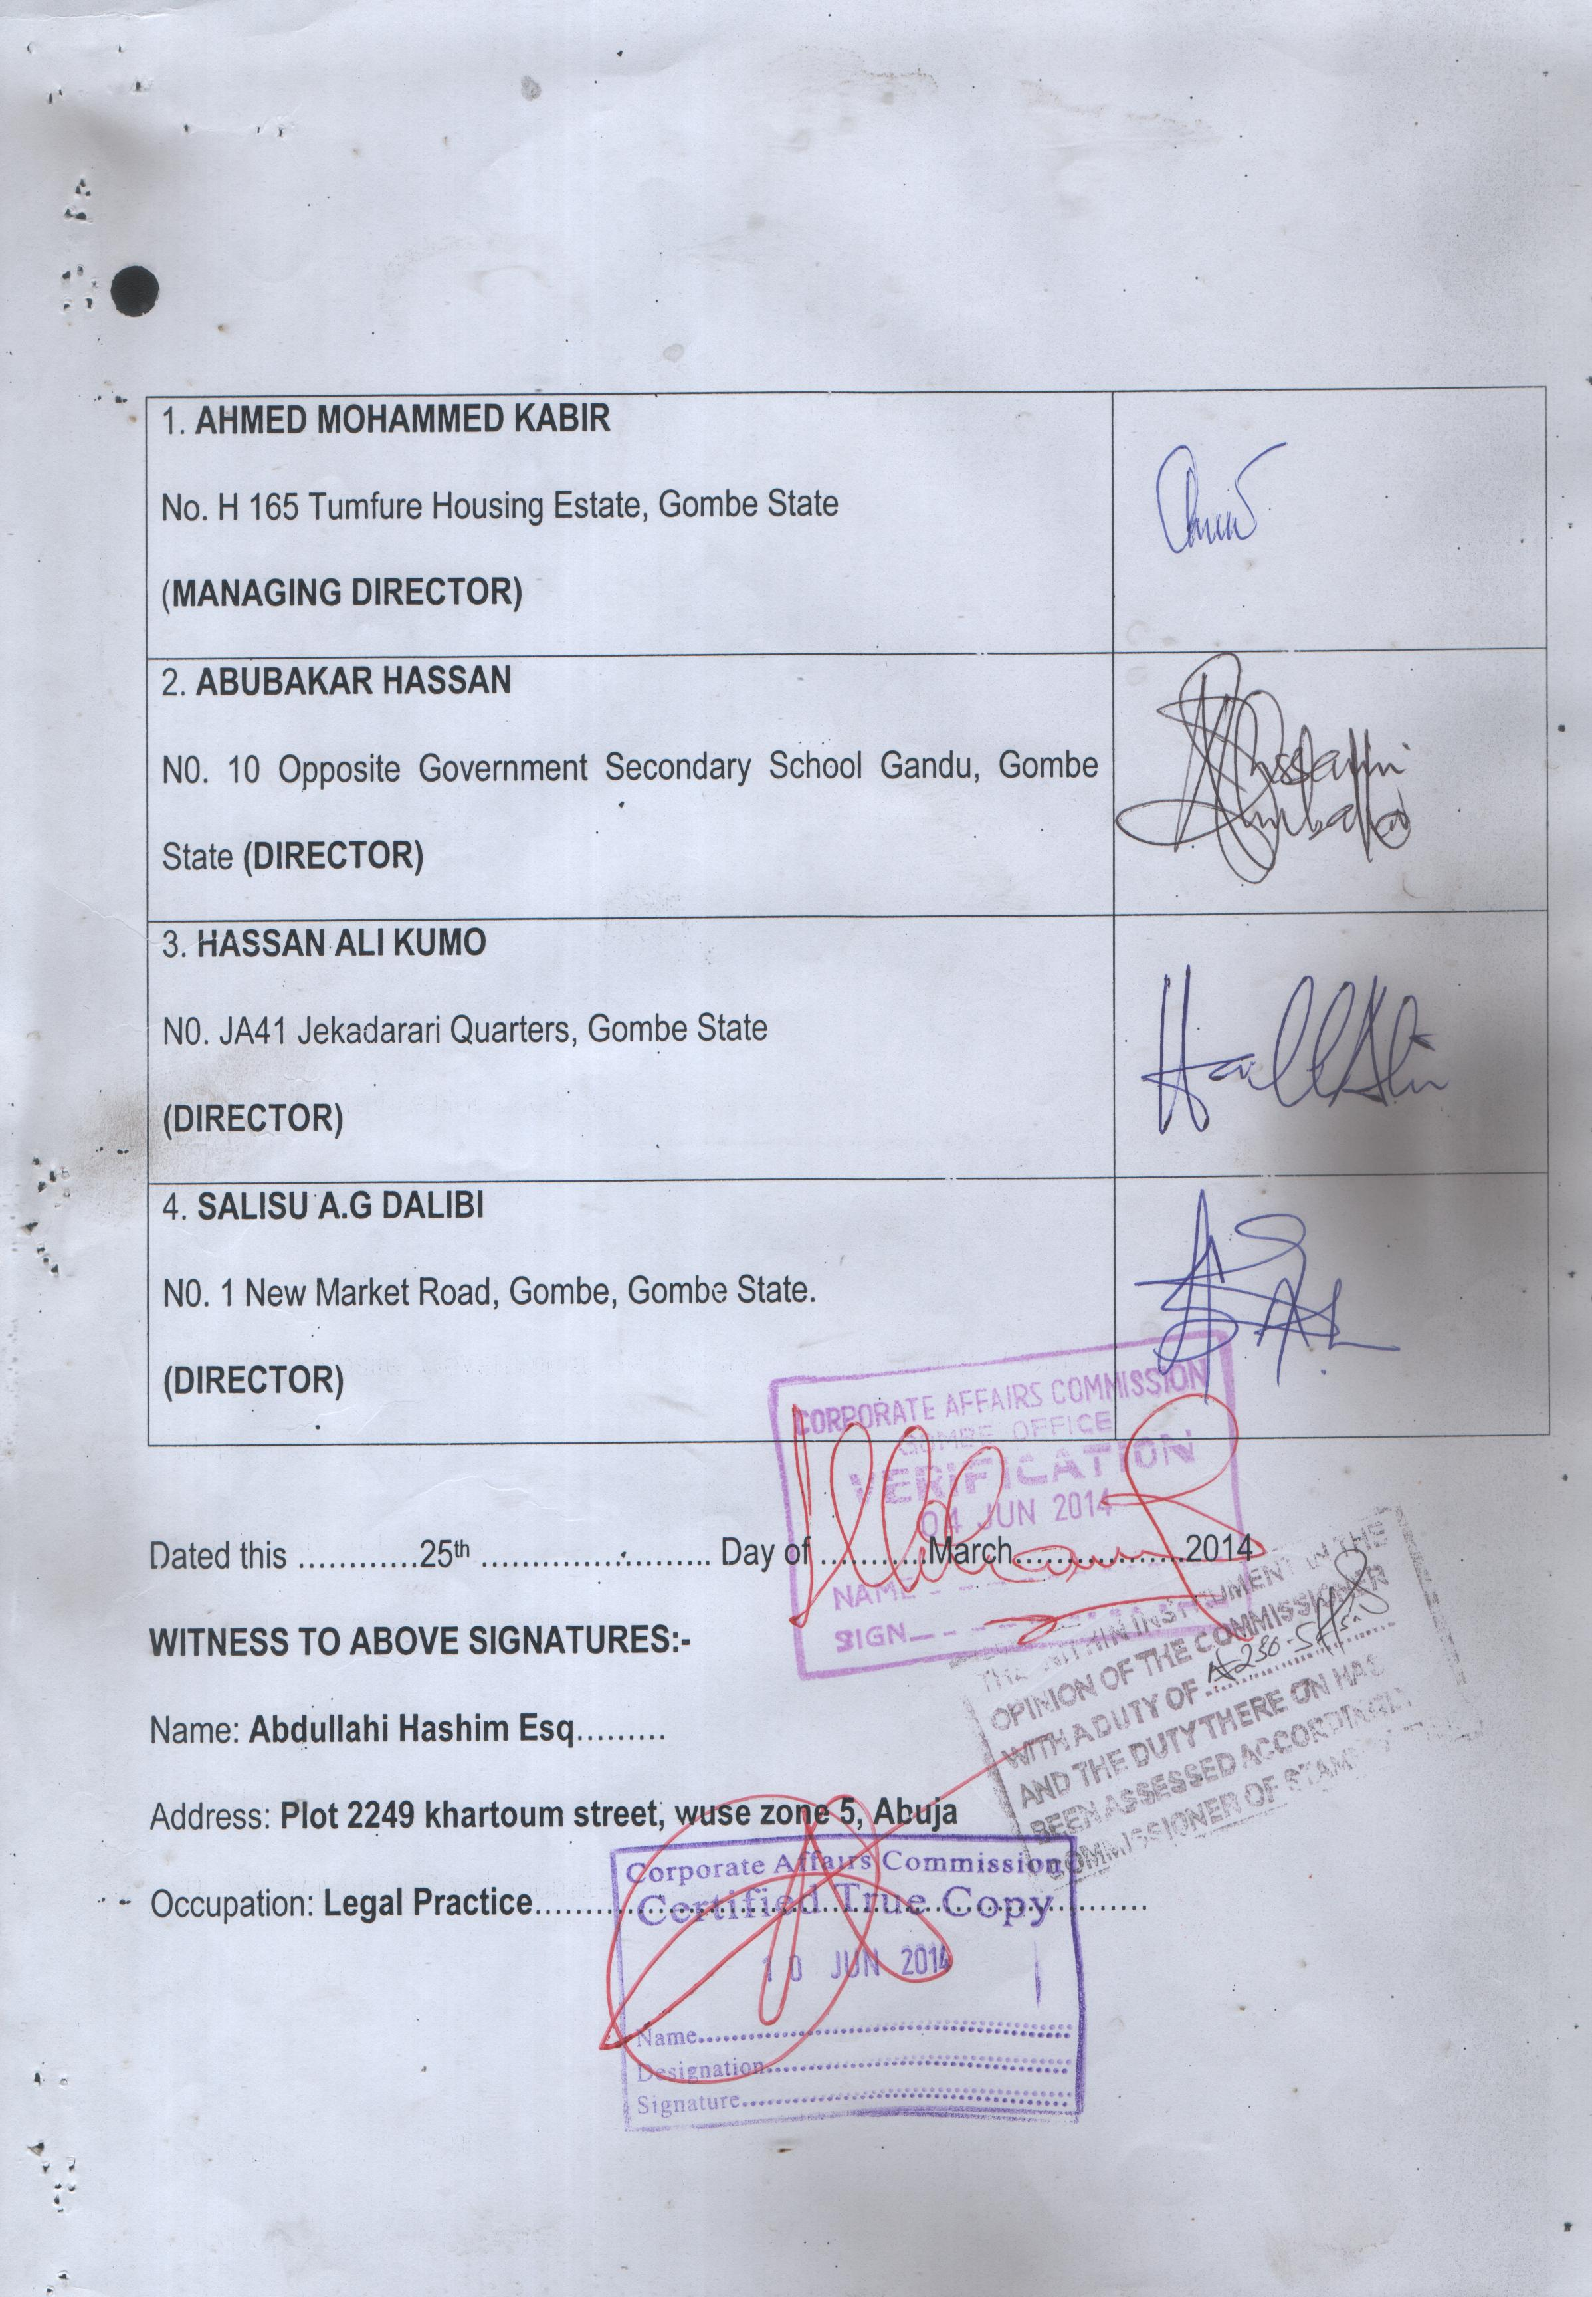

­

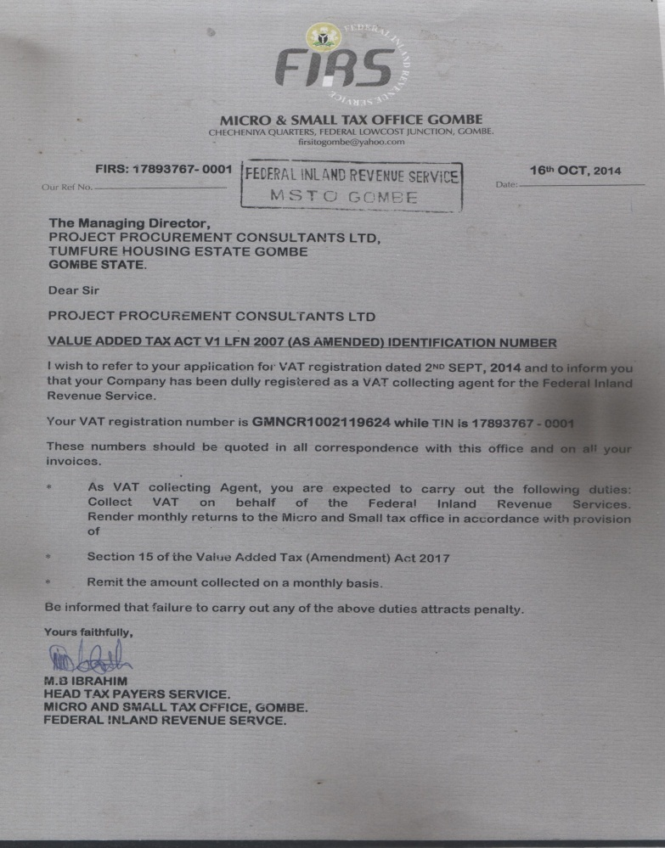

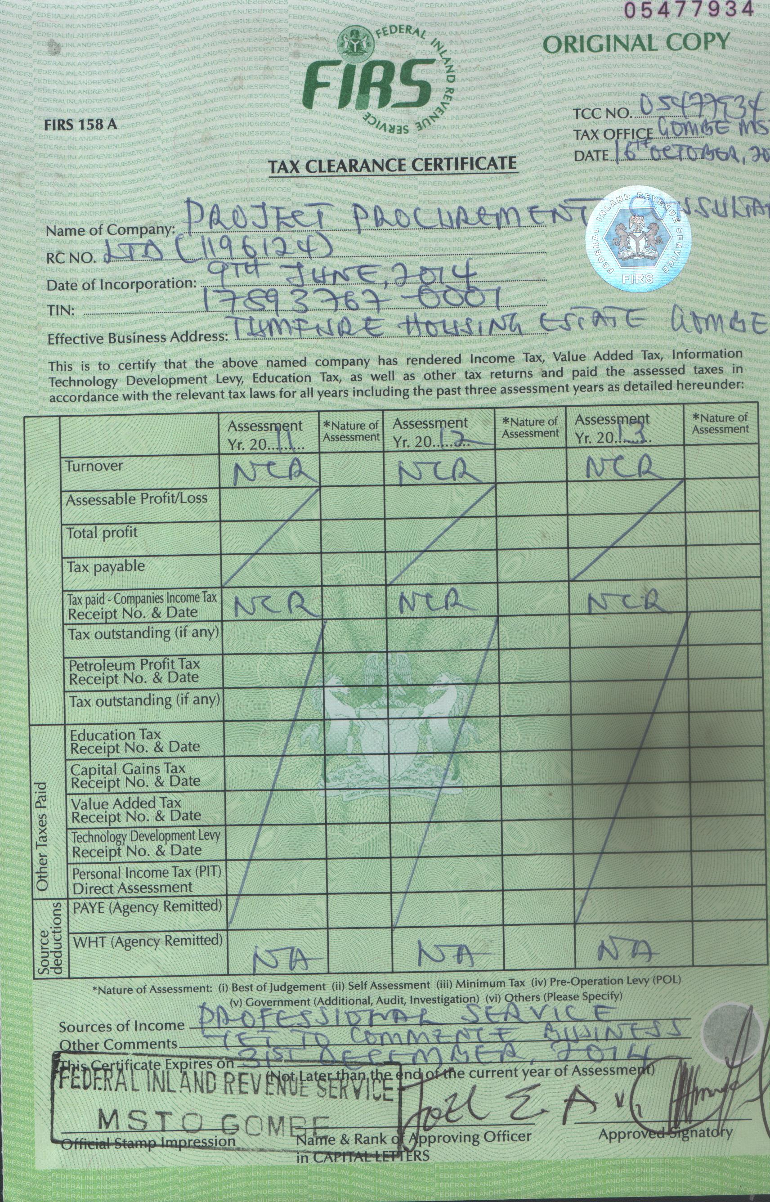

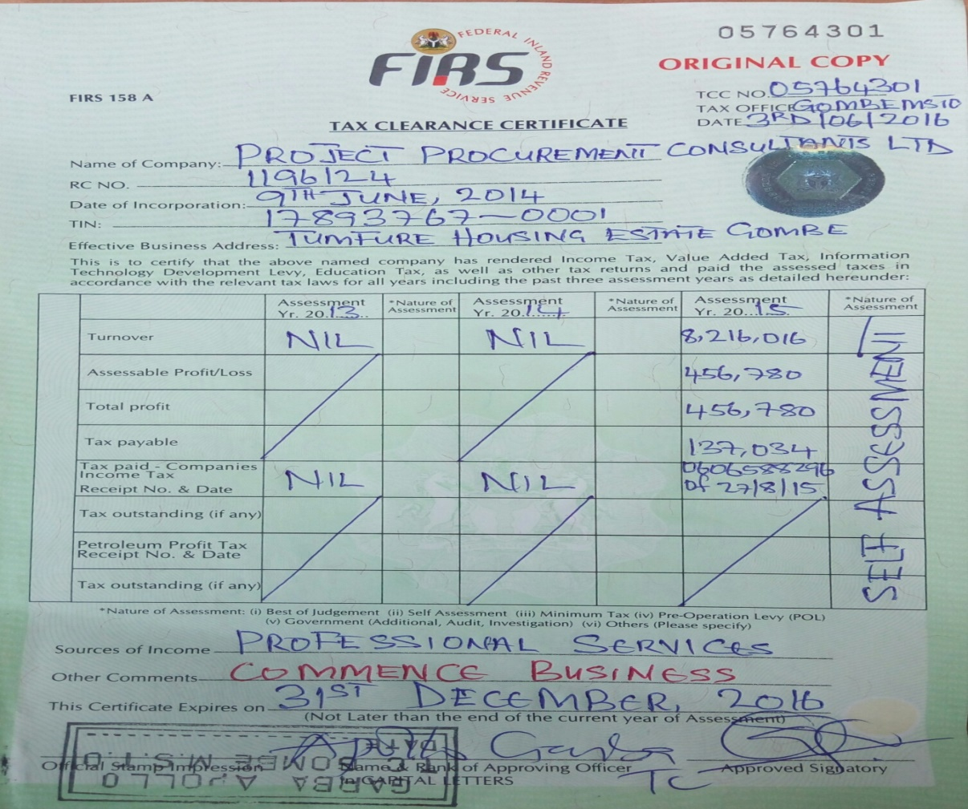





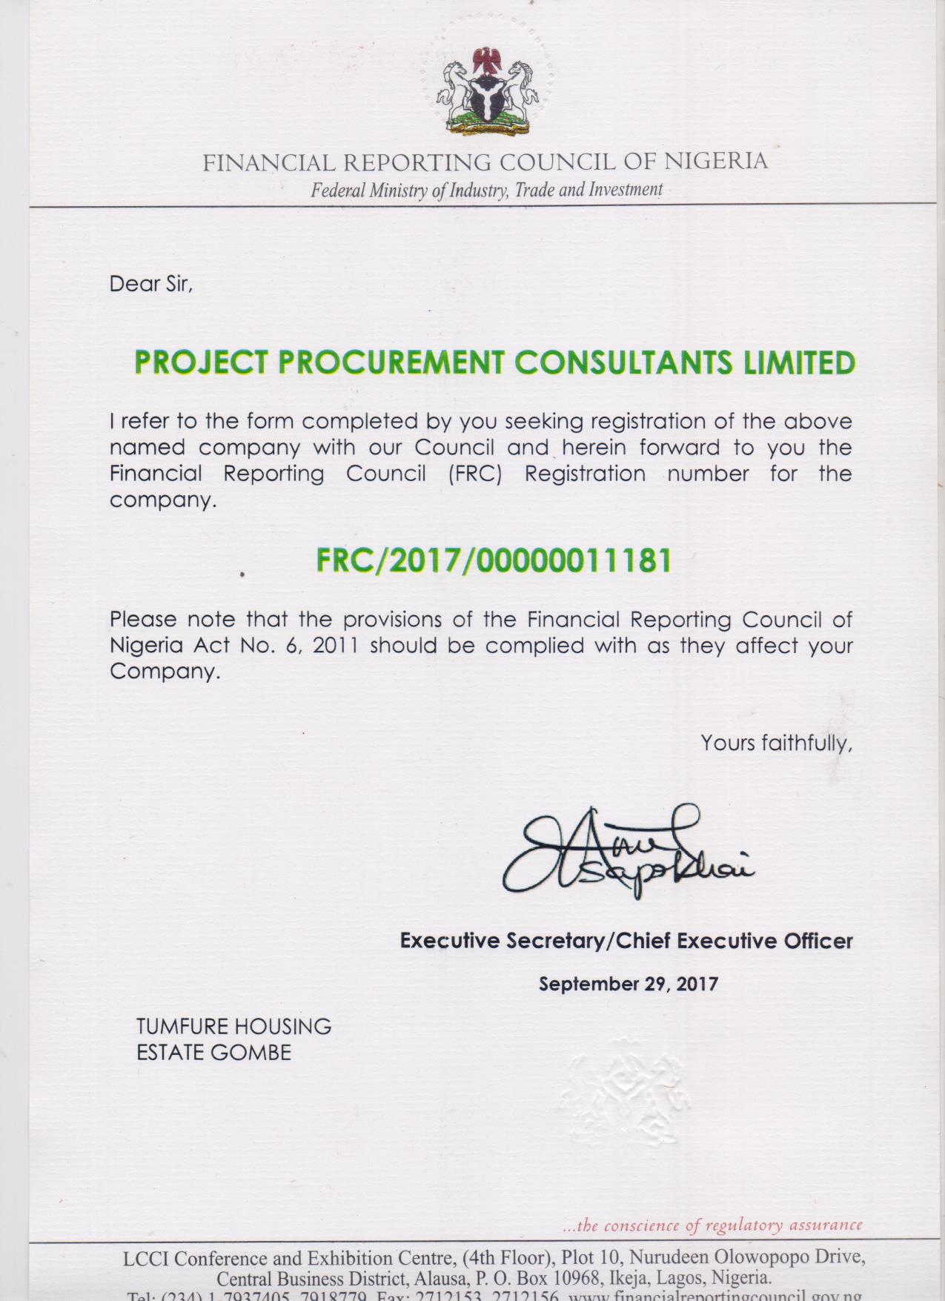



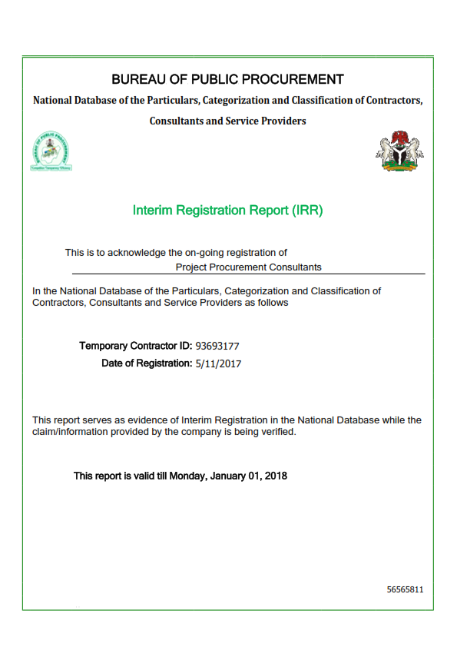



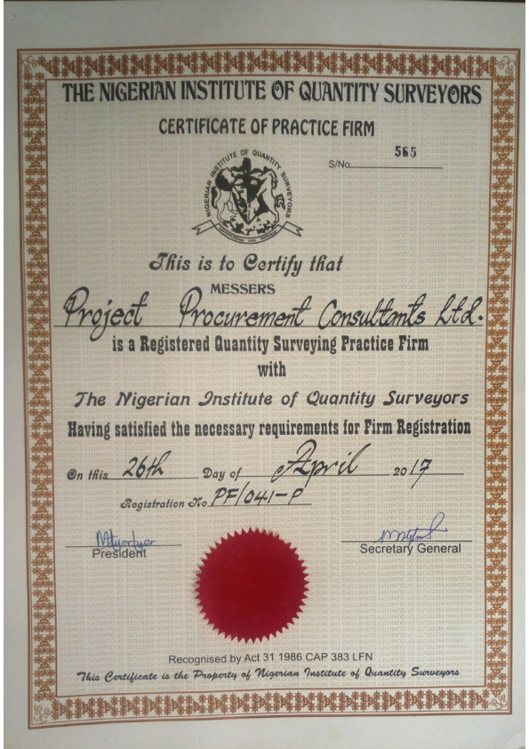

**REGISTERED ADDRESS:**

H165 Tumfure Housing Estate Gombe, Gombe State.

**CURRENT BUSINESS ADDRESS:**

Suite A7, Duwa Plaza, Plot 47 Bauchi Road Gombe, Gombe State.

**PHONE NUMBERS:**

(+234) 803 6851 385

(+234) 803 5539 340

**EMAIL ADDRESS:**

ppcconsultants2014@gmail.com

**CONTACT PERSON:**

Ahmad Muhammad Kabir

[amk882@gmail.com](mailto:amk882@gmail.com)

+234 80 3685 1385

**MAJOR CLIENTELE:**

* Gombe State University
* Federal college of Horticulture Dadin kowa

SECTION III **PROFILE OF STAFF/STRATEGIC PARTNERS**

Partners

Other Staff

Strategic Partners – Individual Consultants

**ABUBAKAR HASSAN**

**{B.Tech QS, Msc Const. Mgt}**

|  |  |
| --- | --- |
| **POSITION IN FIRM** | |
|  | Managing Partner | |
| **KEY AREAS OF COMPETENCE/SPECIALIZATION** | |
|  | * Contract Documentation * Cost Management * Project Management | |
| **CONTACT ADDRESS** | |
|  | No; 102, off G.D.S.S Gandu road Tudun wada (“C”) Gombe, Gombe State.  Email: [hassanabubakar459@gmail.com](mailto:hassanabubakar459@gmail.com)  Phone: +234 80 3553 9340 | |
| **MARRITAL STATUS** | |
|  | Married | |
| **PROFESSIONAL MEMBERSHIPS** | |
|  | Full Member, Quantity Surveyors Registration Board of Nigeria. **RQS**(1979)  Full Member, Nigerian Institute of Quantity Surveyors , **MNIQS (**2731) | |
| **PROFILE** | |
|  | * Abubakar Hassan has more than 10 years’ experience in construction cost and project management. He is a Quantity Surveyor and has M.Tech in Construction Project Management from Modibbo Adama University of Technology Yola, Nigeria. * He has worked with Messrs Lubel Nigerian Ltd for close to 8 years as trainee/project Quantity Surveyor and rose to become Project Quantity Surveyor/Manager. * He has been an individual consultant to many contractors on (EU-Sign PROJECTS) in Nigeria and wide range of building construction projects. | |
| **PROFESSIONAL EXPERIENCE (SELECTED PROJECTS)** | |
|  | * Graduate /Trainee Quantity Surveyor, Construction of Gombe State University Phase I (2006-2008) * Project Quantity Surveyor, Construction of Banquet Hall, Government House Gombe (2008-2009). * Project Quantity Surveyor, Construction of Faculty of Medicine, Gombe State University Gombe (2009-2010). * Project Manager/Quantity Surveyor, Construction of Mechanical Engineering Dept. PTDF Universities Up-Grade project (2010-2011). * Project Manager/Quantity surveyor , Construction of Faculty Buildings in Federal Univ. Kashere, Gombe state (2011-2012) * Project Manager/ Quantity Surveyor, Renovation and Upgrading of G.A.C Gombe(Gombe state schools turn-around project) 2011-2012 * Project Manager/ Quantity surveyor, Construction of Basic Infrastructure at SBRS Kumo Gombe State University (2011-2012) * Project Manager Construction 500 seat capacity Lecture theatre at G.S.U Gombe. * Lead Consultant Presidential Intervention For Gombe State University Gombe- Needs Assessement Phase II. | |
| **LANGUAGES** | |

English, Hausa, Tera.

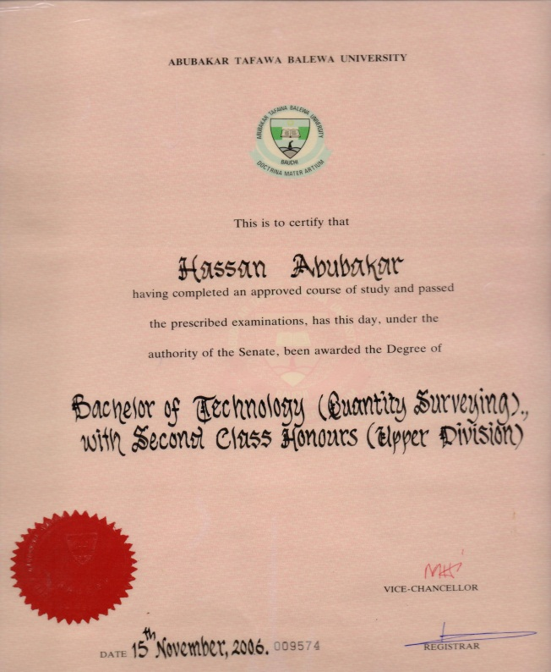 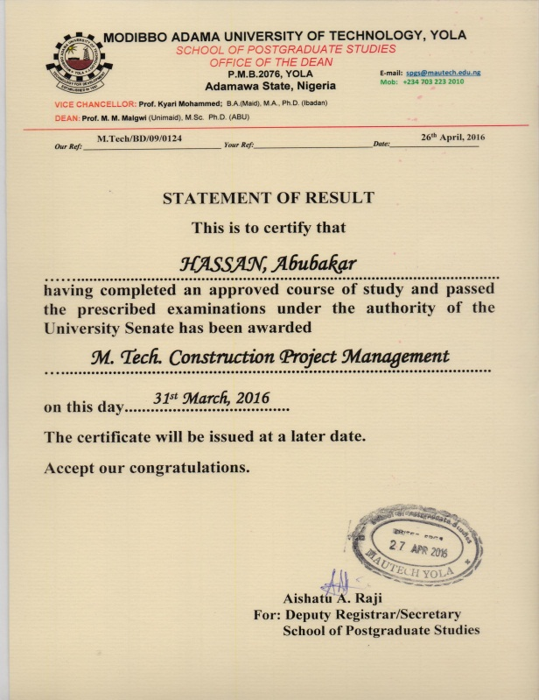

 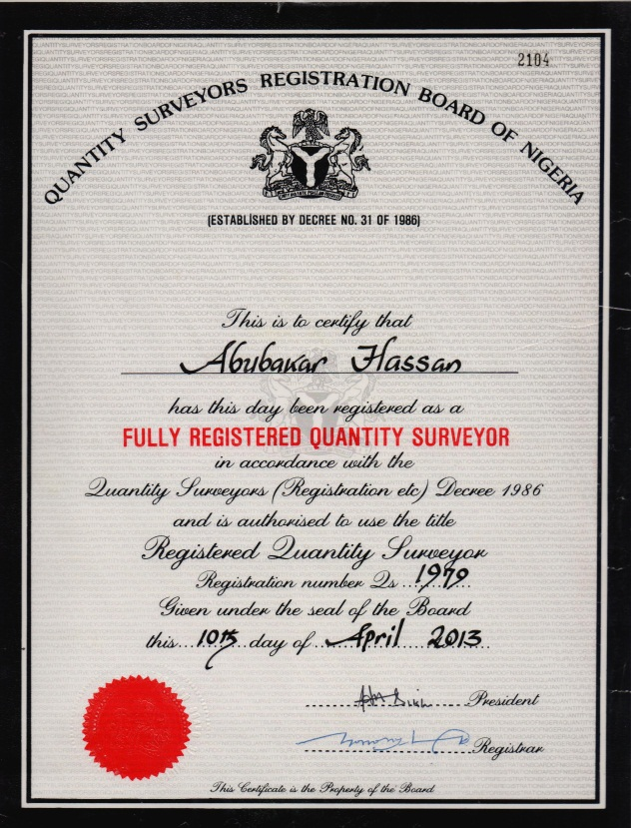

**AHMAD MUHAMMAD KABIR**

**{B.Tech QS}**

|  |  |
| --- | --- |
| **POSITION IN FIRM** | |
|  | Senior Partner | |
| **KEY AREAS OF COMPETENCE/SPECIALIZATION** | |
|  | * Contract Documentation * Contract/Claim Management * Procurement Advisory | |
| **CONTACT ADDRESS** | |
|  | H165 Tumfure Housing Estate Gombe, Gombe State.  Email: [amk882@gmail.com](mailto:amk882@gmail.com)  Phone: +234 80 3685 1385 | |
| **MARRITAL STATUS** | |
|  | Married | |
| **PROFESSIONAL MEMBERSHIPS** | |
|  | Full Registration, Quantity Surveyor Registration Board of Nigeria (**QSRBN**) R/2182-2013  Member, Nigerian Institute of Quantity Surveyors ( **MNIQS** ) 2868 -2013 | |
| **PROFILE** | |
|  | * Ahmad obtained his Bachelors of Technology in Quantity Surveying from Abubakar Tafawa BAlewa University Bauchi, and had his Professional Training at OHIO SAYE & ASSOCIATES (Youth Service) and Y.S Associates { Trainee- Chater}. * His Professsional Training and Career has all been in the Construction Consultancy Sector; he has participated on several Public and Priavate Sector Project(s) and also worked and esterblished relationship with diffrent professional service firm(s) (Architects, Engineers, Lawyers). * He has been actively involved in Community and Professional Association Services; currently, he is the Chairperson Young Quantity Surveyors Forum. | |
| **PROFESSIONAL EXPERIENCE (SELECTED PROJECTS)** | |
|  | ***Y.S Associates No 6 Malnje Street Wuse Zone 4* Abuja, Nigeria.**   * Participated in Construction and Renovation of General Hospital Tallasse, Kashere, and Dukku, Bajoga and Zambuk all in Gombe State, as an Assistant Resident Quantity Surveyor. * Participated in Construction of Pantami Stadium, Gombe, Gombe State, as Assistant Resident Quantity Surveyor and rose to Resident Quantity Surveyor. * Involved (as team member) in the Pre Contract Activities for the Proposed Renovation of Central Bank of Nigeria (CBN) Branch Building in Jos, Plateau State; Yola, Adamawa, State; and Owerri, Imo State. * Worked as Resident Quantity Surveyor and now as Senior Resident Quantity Surveyor for the Renovation of CBN Branch Building Jos.   ***Project Procurement Consultants ltd.***   * Senior Consultant Quantity Surveyor/Contract Administrator on Presidential Intervention For Gombe State University Gombe- Needs Assessement Phase II. | |
| **EDUCATION** | | |
|  | **[ 2001 – 2006 ] AbubakarTafawaBalewa University Bauchi, Nigeria.**   * Degree in Quantity surveying   (B.Tech Quantity surveying)  **[ 1993 – 1999] Federal Government College, Azare Bauchi, Nigeria.**   * Senior secondary school certificate   (S.S.C.E)  **[ 1988 – 1992 ] C.O.E Staff School, Azare Bauchi, Nigeria.**   * Primary school leaving certificate. | |
| **LANGUAGES** | |
|  | English, Hausa, Fulfulde | |

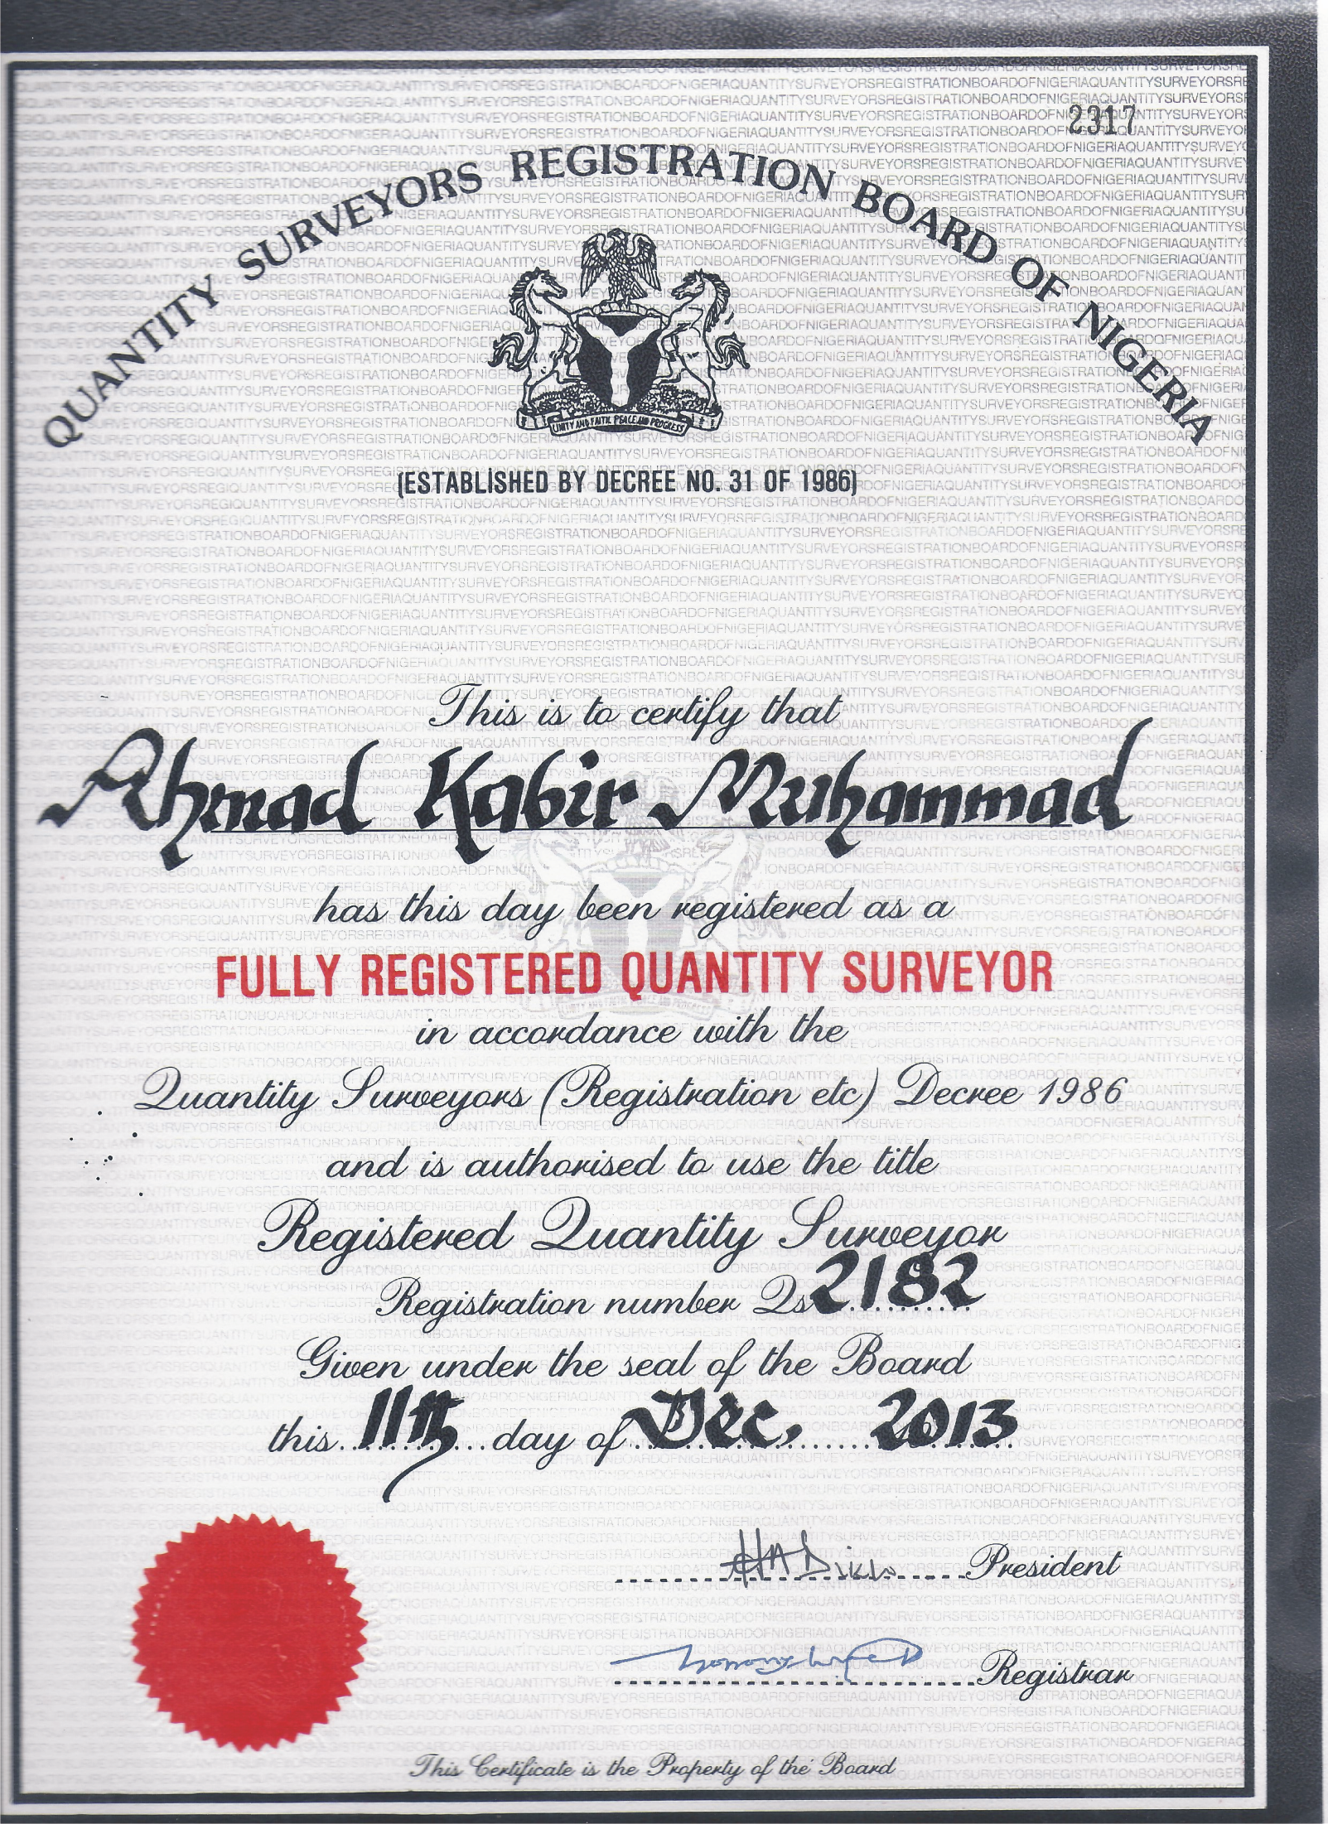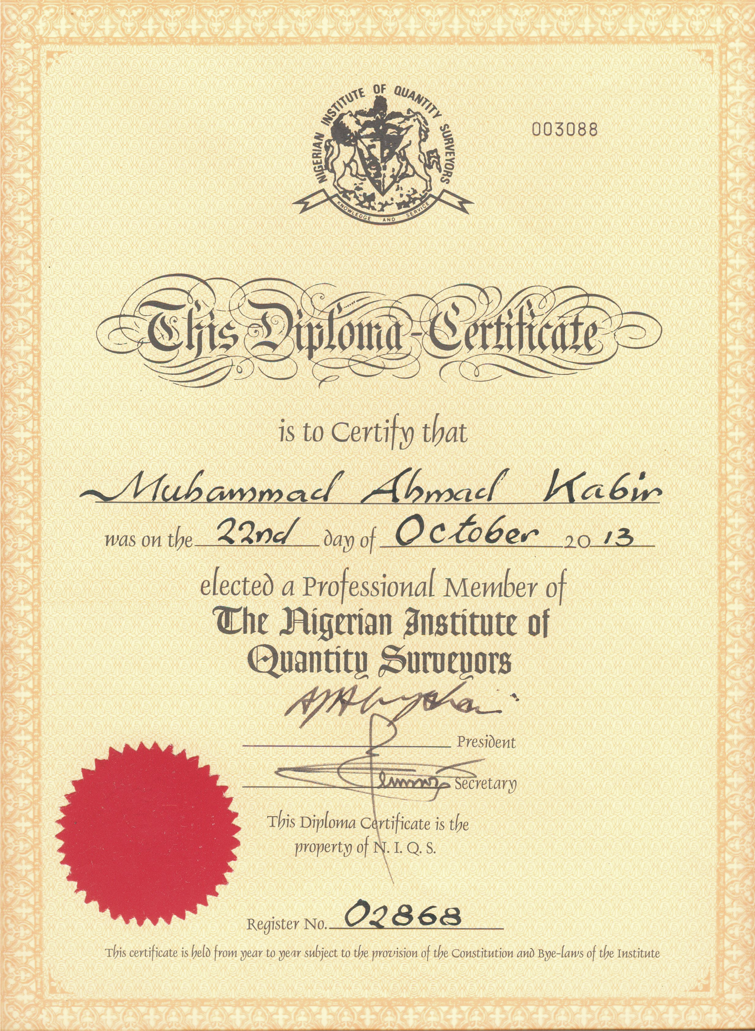



**HASSAN ALI KUMO**

**{B.Tech QS, Msc Const. Mgt}**

|  |  |
| --- | --- |
| **POSITION IN FIRM** | |
|  | Senior Partner | |
| **KEY AREAS OF COMPETENCE/SPECIALIZATION** | |
|  | * Contract Documentation * Cost Management * Project Management * Procurement Advisory | |
| **CONTACT ADDRESS** | |
|  | No. JA 41 Jekadafari Quarters Gombe, Gombe State.  Email: [halikumo@gmail.com](mailto:halikumo@gmail.com)  Phone: +234 80 3586 1304 | |
| **MARRITAL STATUS** | |
|  | Married | |
| **PROFESSIONAL MEMBERSHIPS** | |
|  | Full Registration, Quantity Surveyor Registration Board of Nigeria (**QSRBN**) R/2844-2016  Member, Nigerian Institute of Quantity Surveyors ( **MNIQS** ) 03676 -2016 | |
| **PROFILE** | |
|  | * Hassan Ali kumo graduated from Abubakar Tafawa BAlewa University Bauchi with 2nd Class Upper Honours, Quantity Surveying; and also attended Ahmadu Bello University Zaria for masters of science construction management. * He has mostly been ivolved on Civil Engineering Projects (Water Supply and Erosion Control). * Hassan has deep knowledge of multilateral project finance,and extensive experience on multilaterally finance projects. | |
| **PROFESSIONAL EXPERIENCE (SELECTED PROJECTS)** | |
|  | ***Sarplast West Africa, No.1Tom Closeoff NileStreet, Maitama Abuja.***   * Project Quantity Surveyor, Bwari Water Supply Project. * Project Quantity Surveyor, Tank 1 and 6 construction for Abuja Water Supply Project. * Assistant Project Manager/Quantity Surveyor ,Kafanchan/Kagoro Water Supply Scheme(World Bank Assisted). * Project Manager, Kaduna North and South Treatment Plant & Civil Works (Wold Bank Assisted). * Project Manager, Upgrading and Rehabilitation of Nasarawa Town Water Supply Scheme. * Project Quantity Surveyor/Estimator, Gully Erosion control Projects at Gombe Town, Gombe State. | |
| **EDUCATION** | |
|  | **[ 2008 – 2012] A.B.U Zaria Kaduna, Nigeria.**   * Masters in construction Management   (MSc Const.Mgt)  **[ 2001 – 2006 ] AbubakarTafawaBalewa University Bauchi, Nigeria.**   * Degree in Quantity surveying   (B.Tech Quantity surveying)  **[ 1993 – 1999] G.S.S Kawo Kaduna, Nigeria.**   * Senior secondary school certificate   (S.S.C.E)  **[ 1984 – 1990 ] Jekadafari Primary school Gombe, Nigeria.**   * Primary school leaving certificate. | |
| **LANGUAGES** | |
|  | English, Fulfulde.Hausa | |

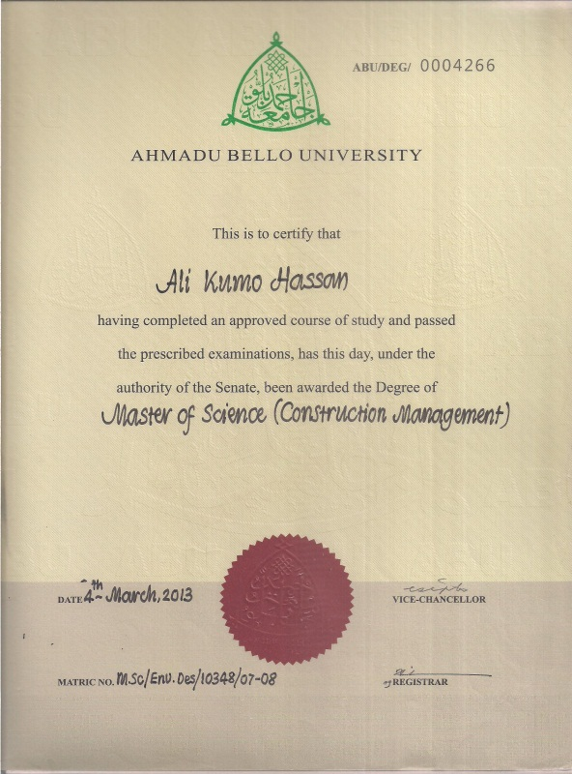

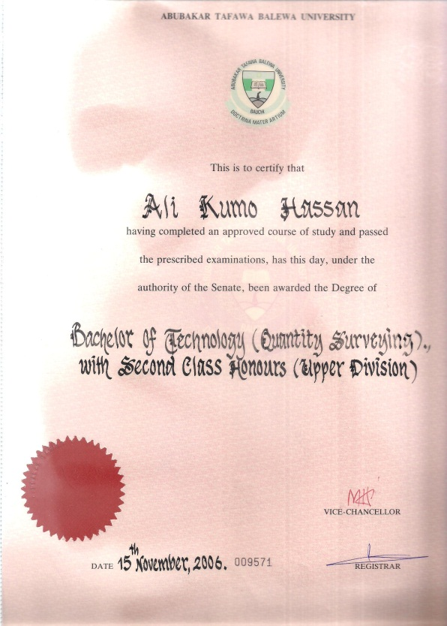

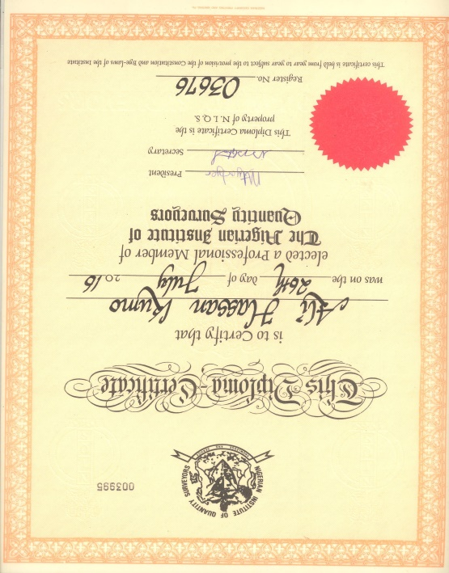 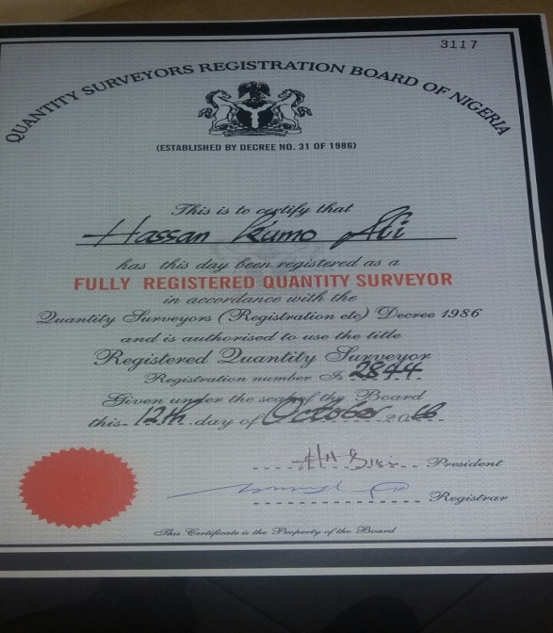

**YUSUF IBRAHIM {B.Tech QS}**

|  |  |
| --- | --- |
| **POSITION IN FIRM** | |
|  | Assistant Consultant - Quantity Surveying/Research | |
| **CONTACT ADDRESS** | |
|  | No .7 Abacha Road, Jekadafari Gombe. Email: yusufmaiwake@gmail.com  Tel: +234(0806)5868722 | |
| **MARRITAL STATUS** | |
|  | Single | |
| **PROFESSIONAL AFFILIATION** | | |
|  | Probationer Member Nigerian Institute of Quantity Surveyors **P00341-I** 2015 | |
| **PROFILE** |  | |

Yusuf was the best graduating student in his class and has authored and presented a research paper at the NIQS RECON, 2015.

**WORKING EXPERIENCE**

* + - 6 months Industrial Training at Y.S Associates, Gombe Project Office.

Participated in the Design & Supervision of Presidential Needs Special Intervention Phase II for Gombe State University, PPC Ltd.

**EDUCATIONAL/OTHER QUALIFICATION(S)**

Abubakar Tafawa Balewa University, Bauchi

B. Tech, Quantity Surveying 2014

Federal Polytechnic, Bauchi

O.N.D Quantity Surveying 2007

|  |  |
| --- | --- |
| **LANGUAGES** | |
|  | English, Hausa, Fulfulde. | |

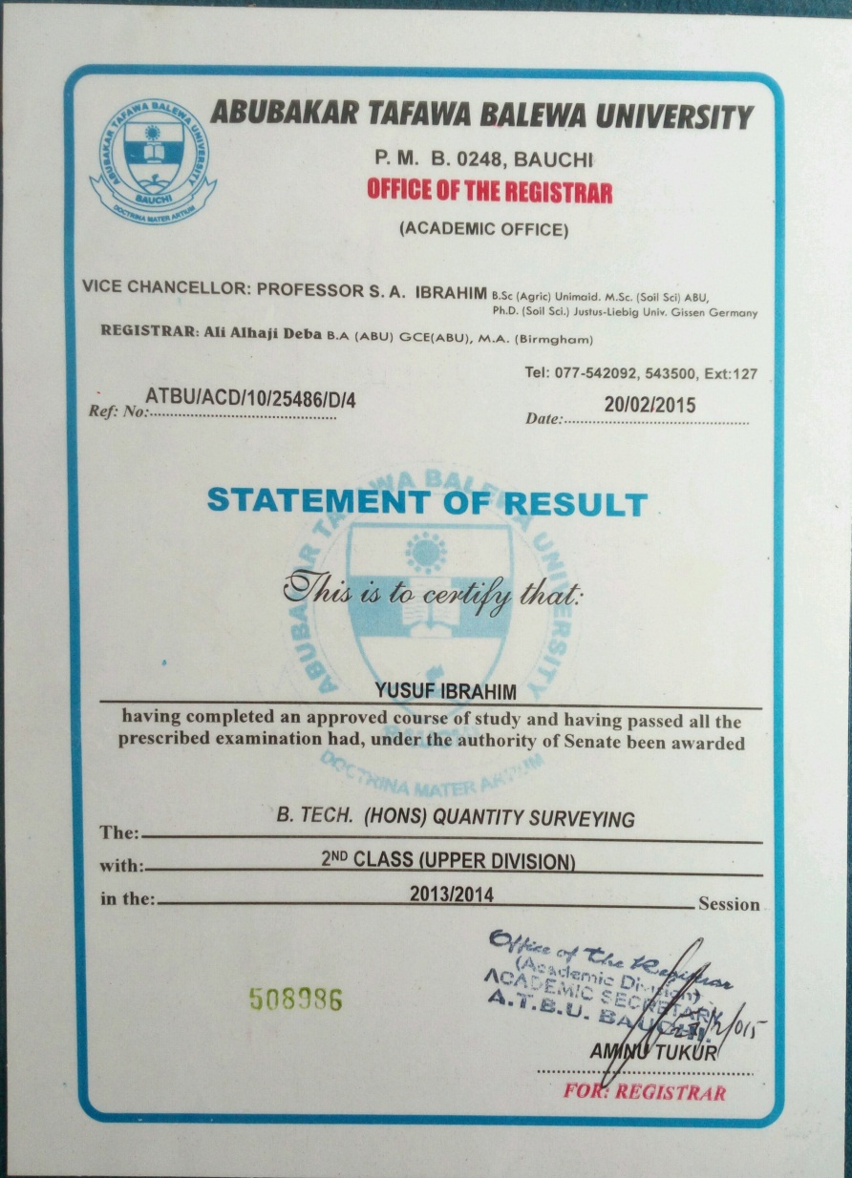

**HARUNA SAIDU**

**{B.Tech QS}**

|  |  |
| --- | --- |
| **POSITION IN FIRM** | |
|  | Assistant Consultant - Quantity Surveying | |
| **CONTACT ADDRESS** | |
|  | No .7 Adjacent P.Z Cussons Nig. Ltd, New Commercial Area, Gombe. Email: Harunachigero@gmail.com  Tel: +234(0803)8869476 | |
| **MARRITAL STATUS** | |
|  | Single | |
| **PROFESSIONAL AFFILIATION** | | |
|  | Probationer Member Nigerian Institute of Quantity Surveyors | |
|  | |

**EDUCATIONAL/OTHER QUALIFICATION(S)**

Abubakar Tafawa Balewa University, Bauchi

B. Tech, Quantity Surveying 2014

**WORKING EXPERIENCE**

* + 6 months Industrial Training at Y.S Associates, Gombe Project Office.
  + Support Staff, National Youth Service Corp (BMPIPPU), Due Process Office, Government House, Bauchi. May 2015 to April 2016
  + Assistant Consultant (Q/S), PPC Ltd, From May 2016 to Date:

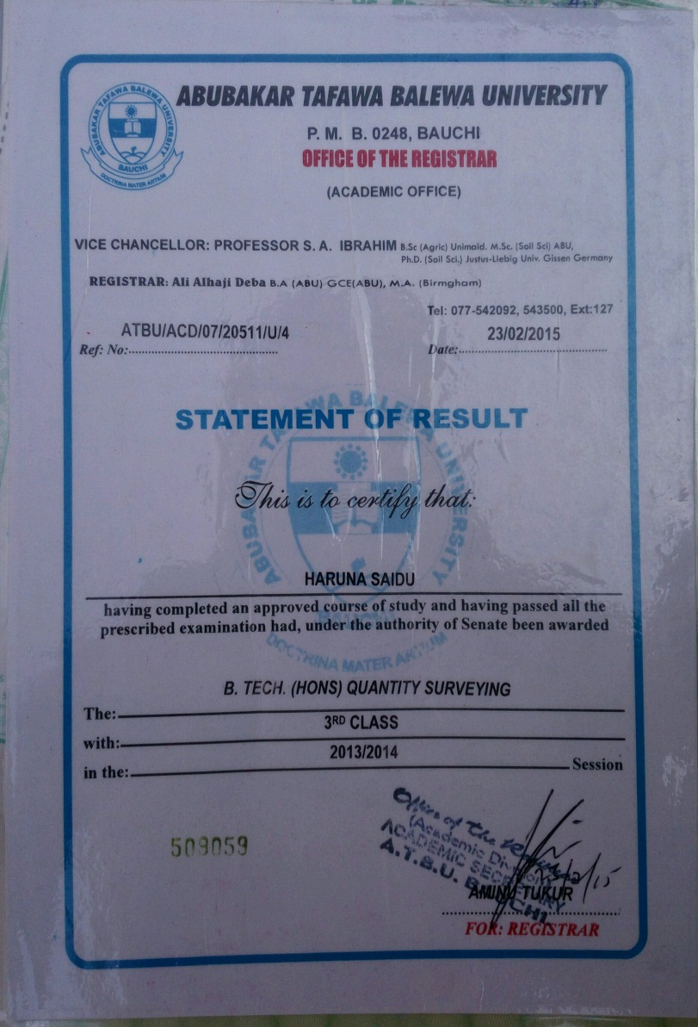

**KWARGANA IMRAN LAWAL**

**{B.Eng.(Hons) Civil Engineering}**

|  |  |
| --- | --- |
| **POSITION IN FIRM** | |
|  | Assistant Consultant – Design: Civil/ Structural Engineering | |
| **CONTACT ADDRESS** | |
|  | Tudun Wada Shamaki Ward, Adjacent Former Governor of Yobe’s Residence, Gombe Gombe State. Email: kwaranganaimran@gmail.com  Tel: +234(0803)7008514, +234(0807)1585888. | |
| **MARRITAL STATUS** | |
|  | Single | |
| **PROFESSIONAL AFFILIATION** | | |
|  | Nigerian Society of Engineers | |
| **PROFILE** |  | |

* Imran attended AbubakarTafawaBalewa University Bauchi, and graduated with a Second Class Upper Honors in Civil Engineering.
* He joined PPC Ltd as an assistant Consultant-Design/Supeervision. He is been trained to esterblish and lead the civil /StructuralEngineering Division of PPCltd.

**WORKING EXPERIENCE**

* + - 6 months Industrial Training at Lubell Nigeria Limited, Abuja.
* Participated in the Design & Supervision of Presidential Needs Special Intervention Phase II for Gombe State University, PPC Ltd.

**EDUCATIONAL/OTHER QUALIFICATION(S)**

Abubakar Tafawa Balewa University, Bauchi

B. Eng. (Hons) Civil Engineering. With Second Class Upper Division 2014

|  |  |
| --- | --- |
| **LANGUAGE** | |
|  | English, Hausa | |

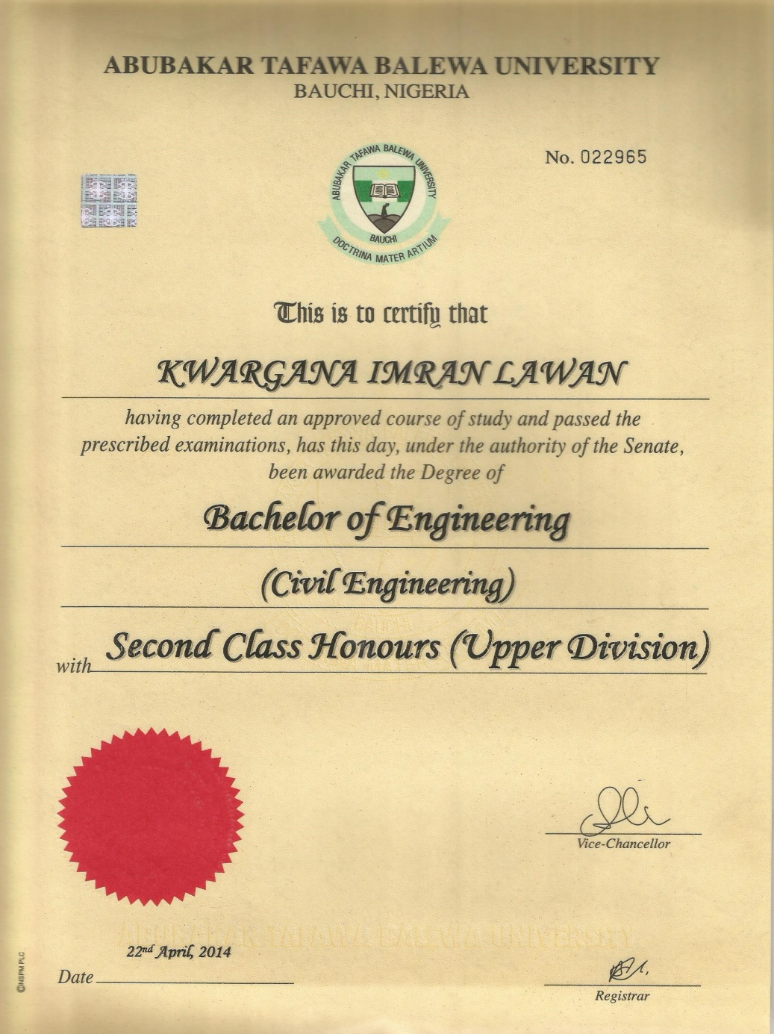

SECTION IV **Verifiable Evidence of Completed/Ongoing Projects**

Letter of Appointment

3D and Pictures of Completed Project(s)



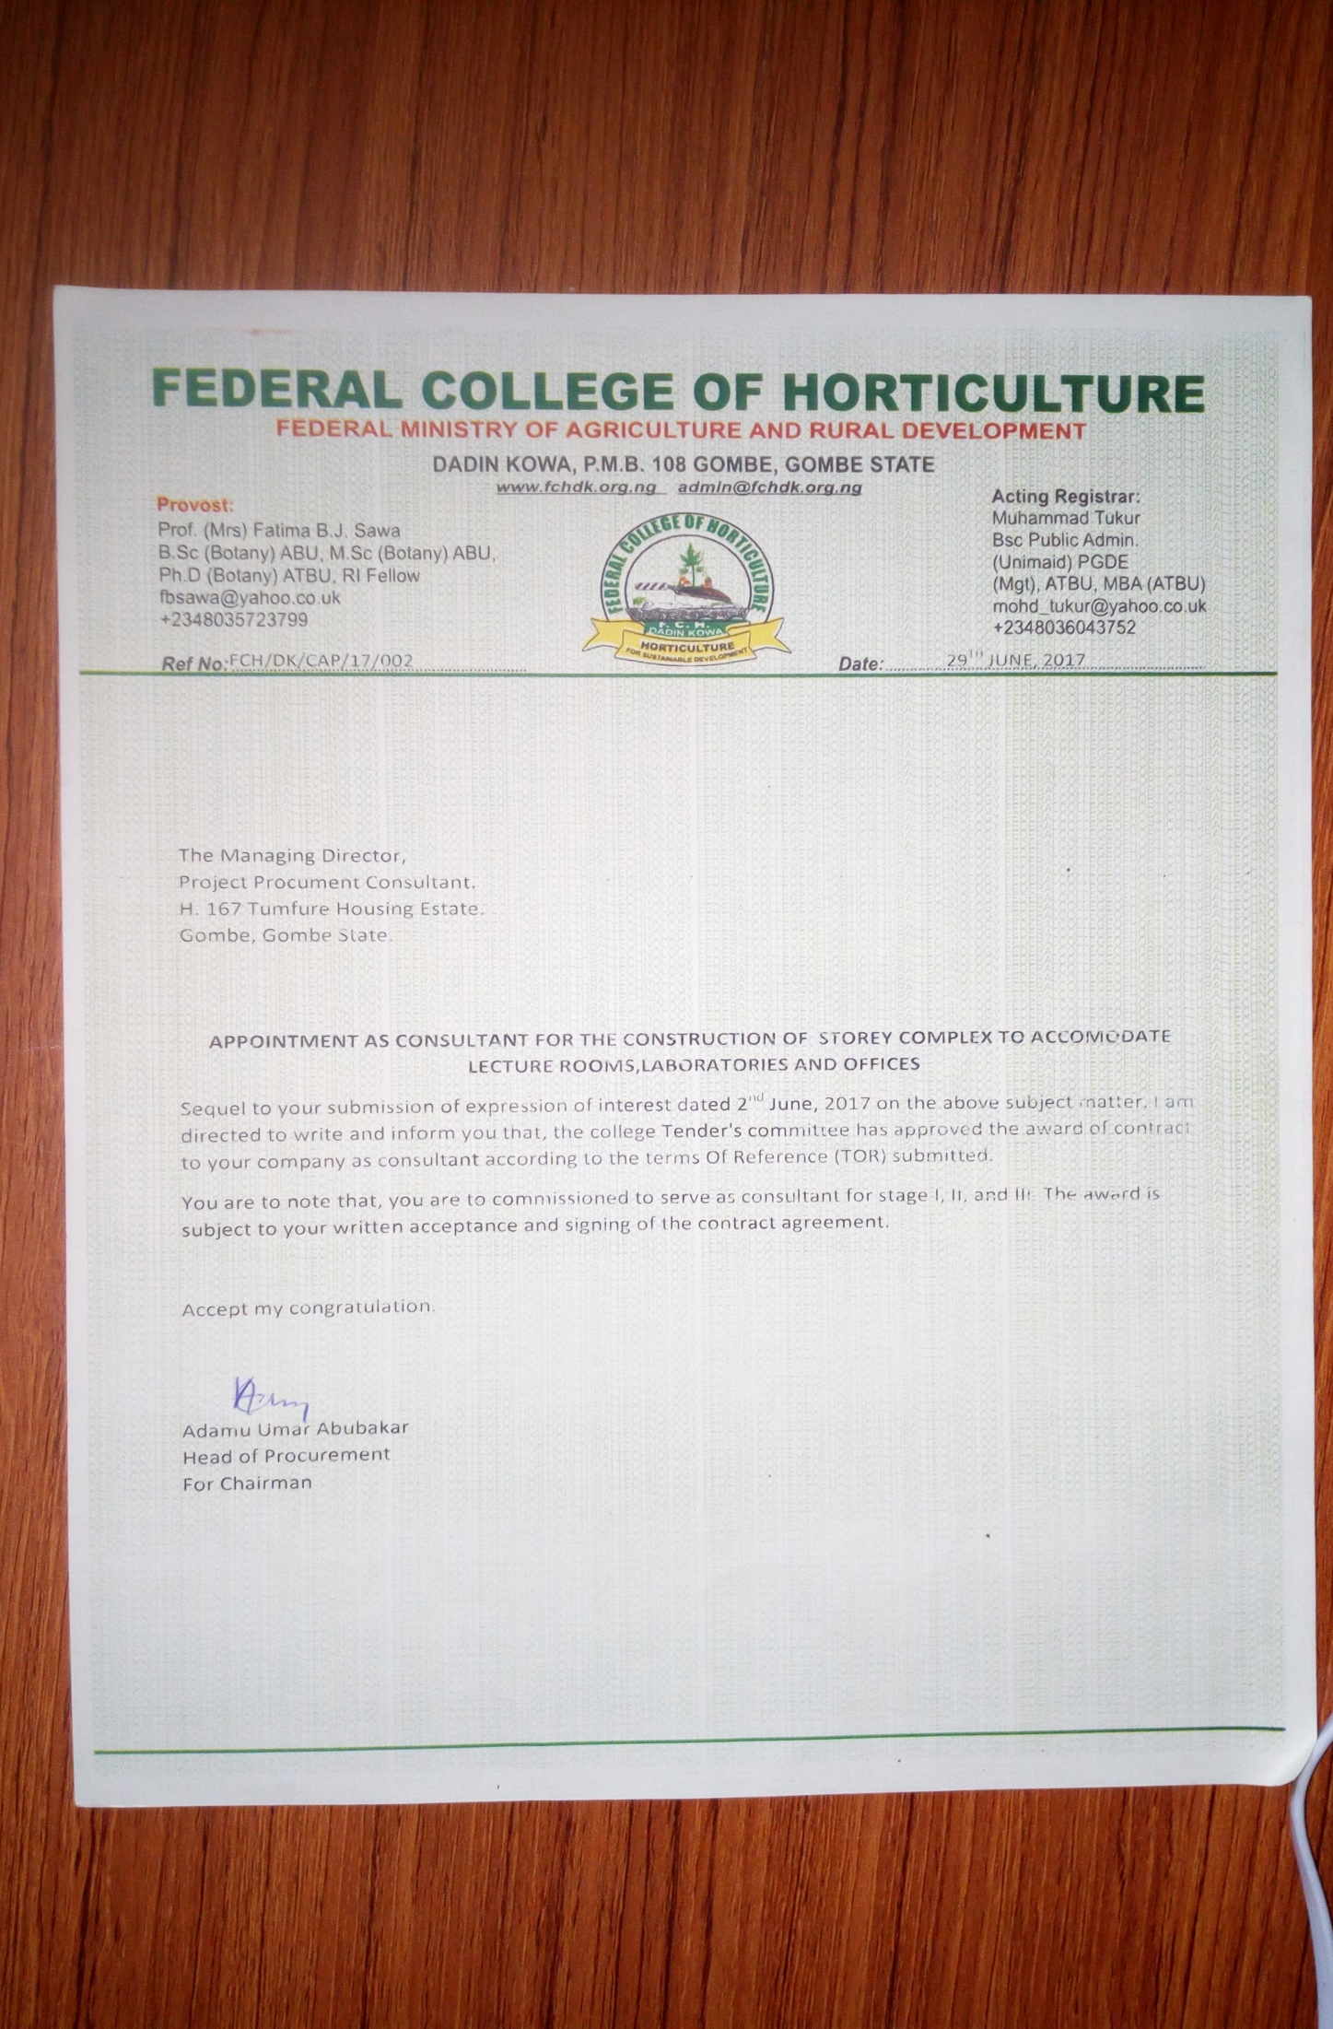

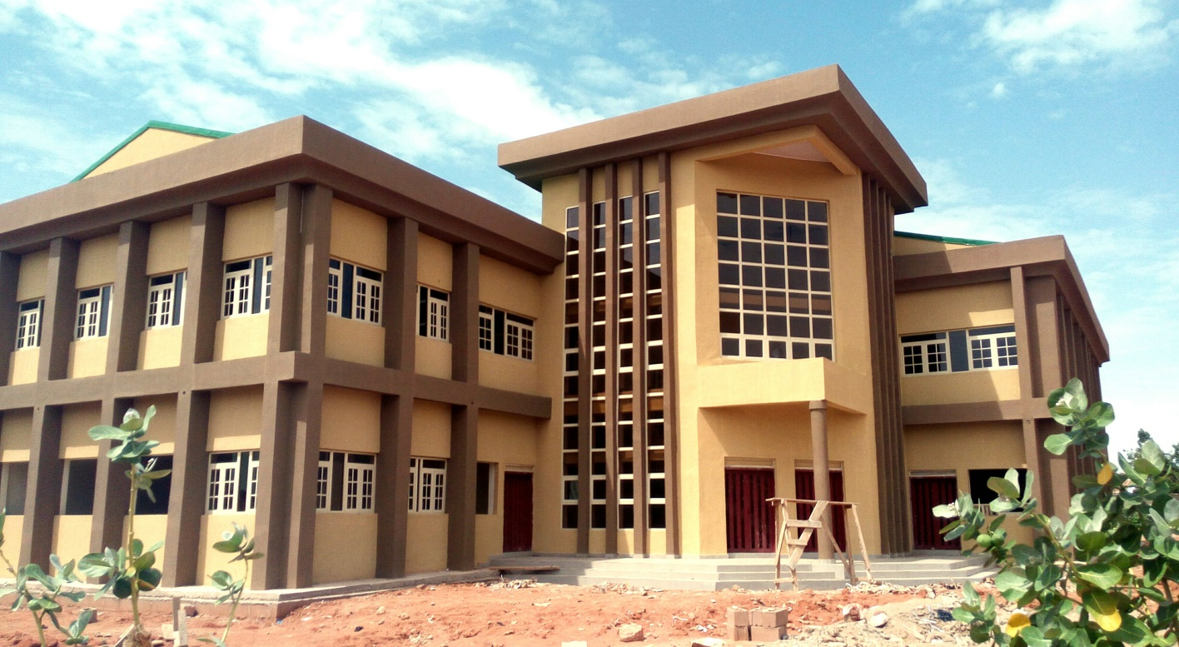

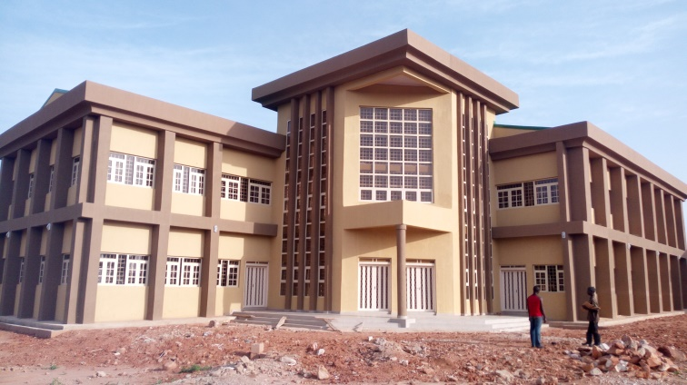

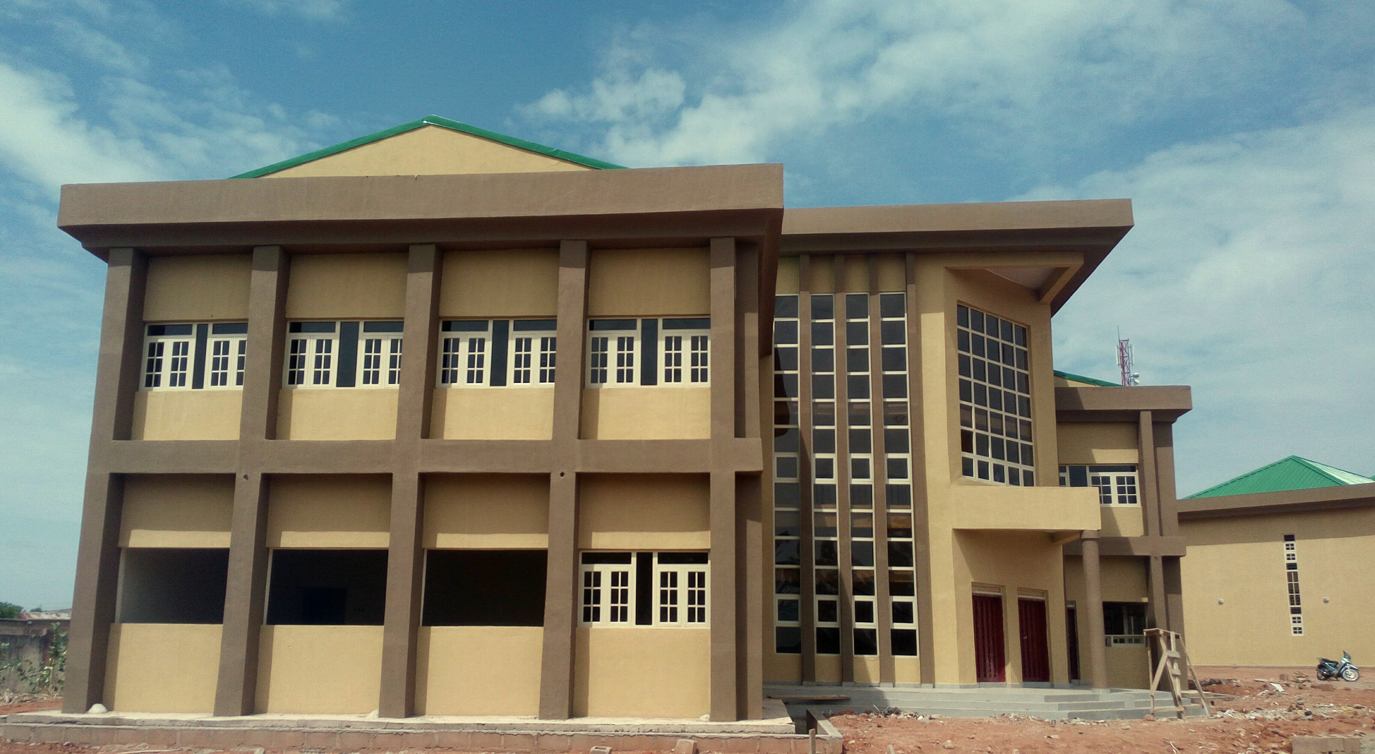

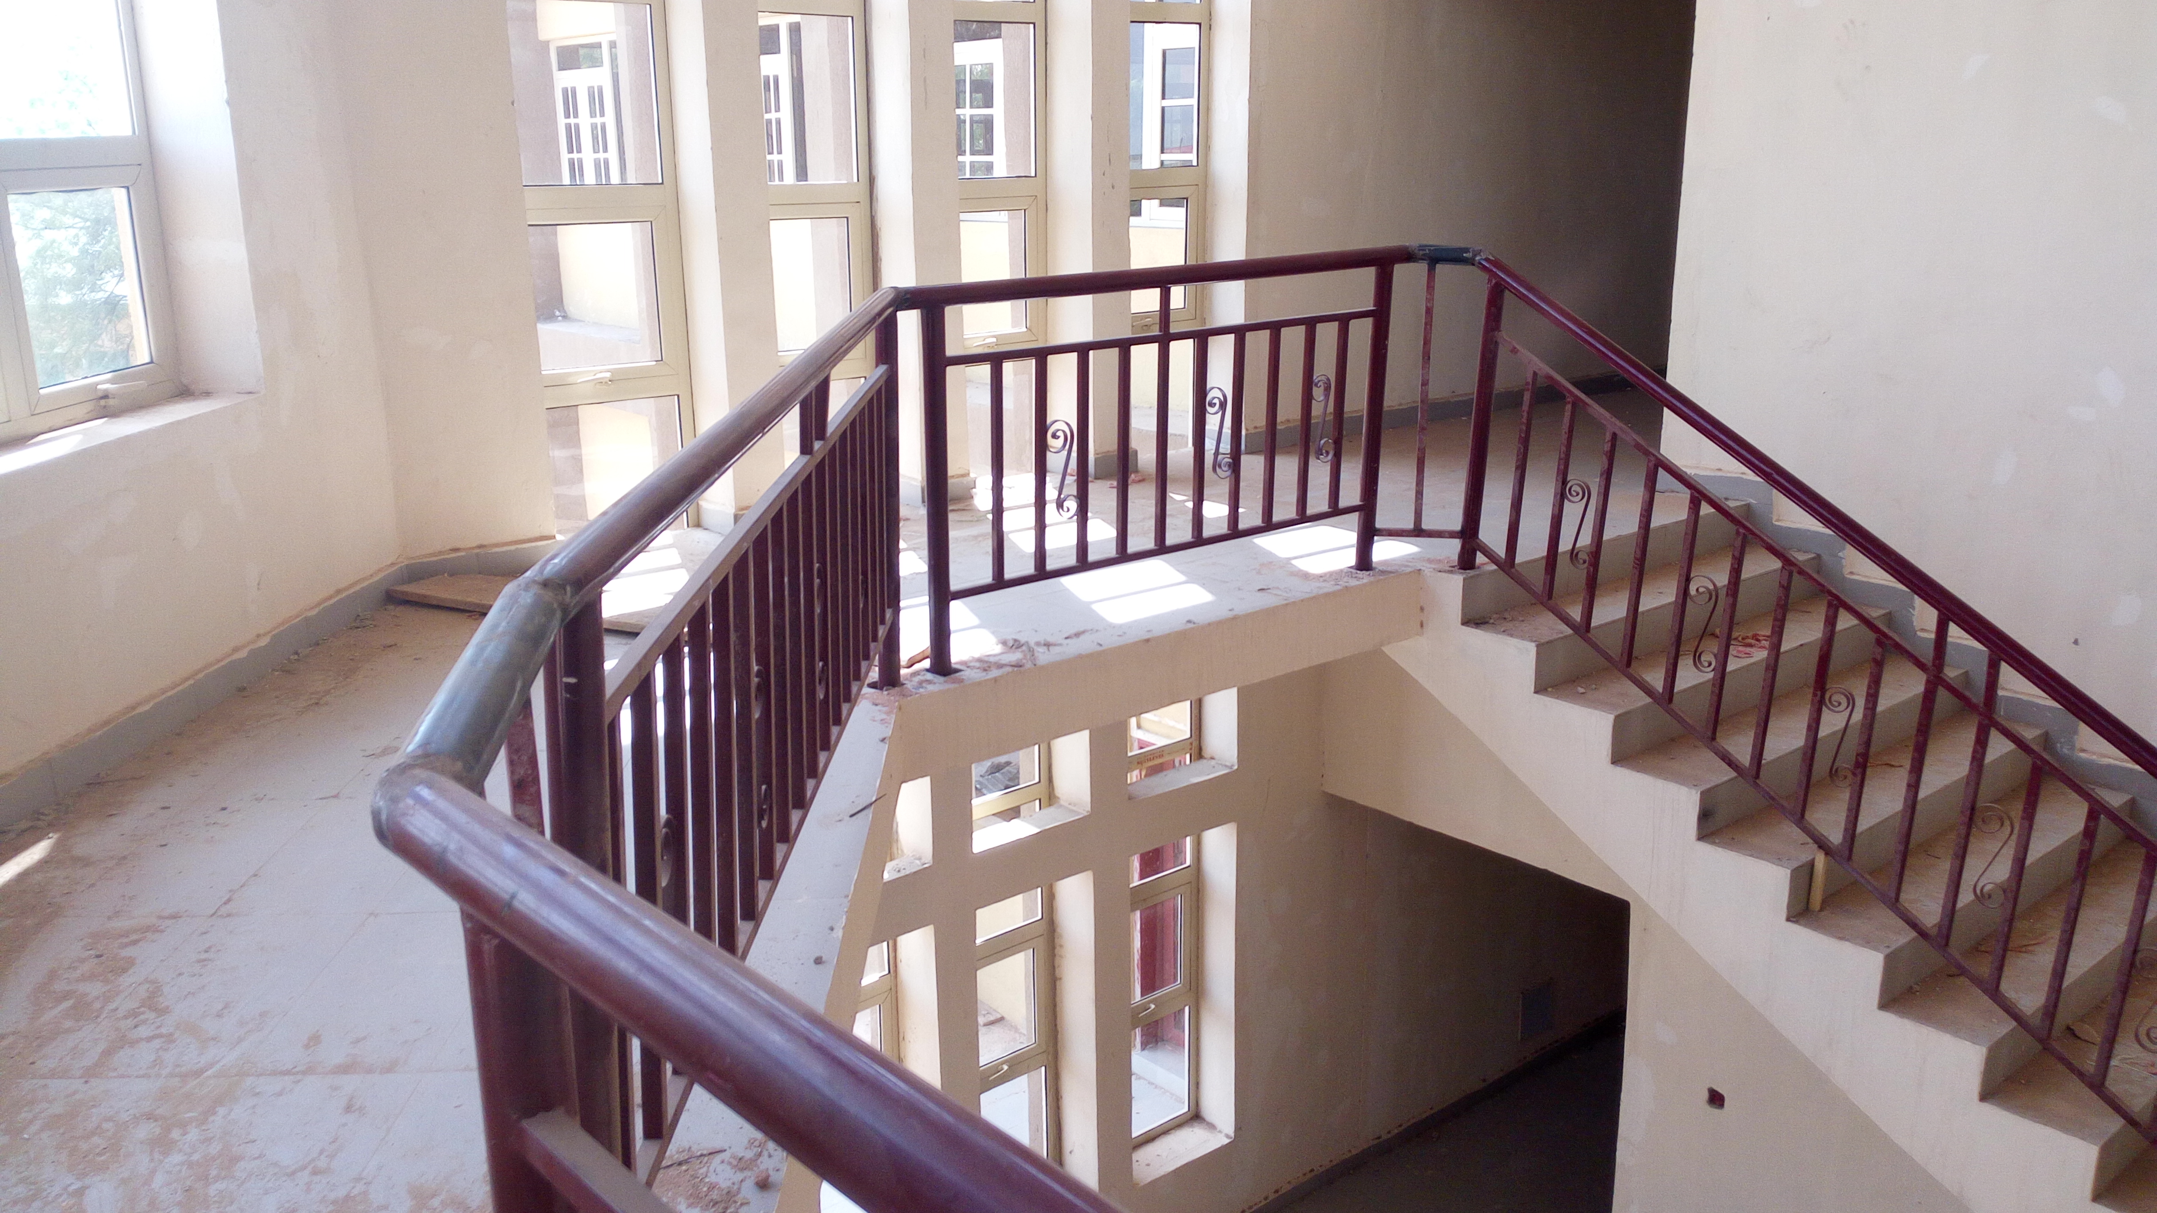

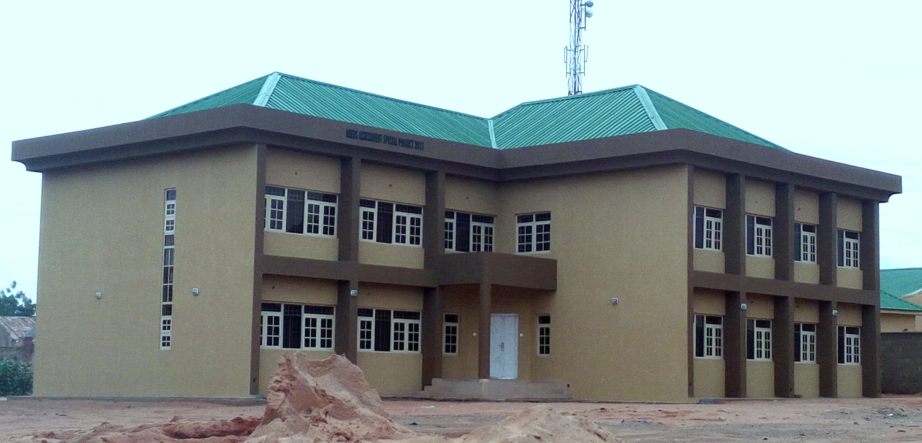

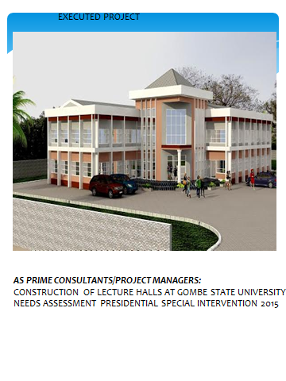

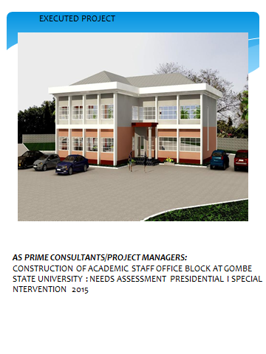

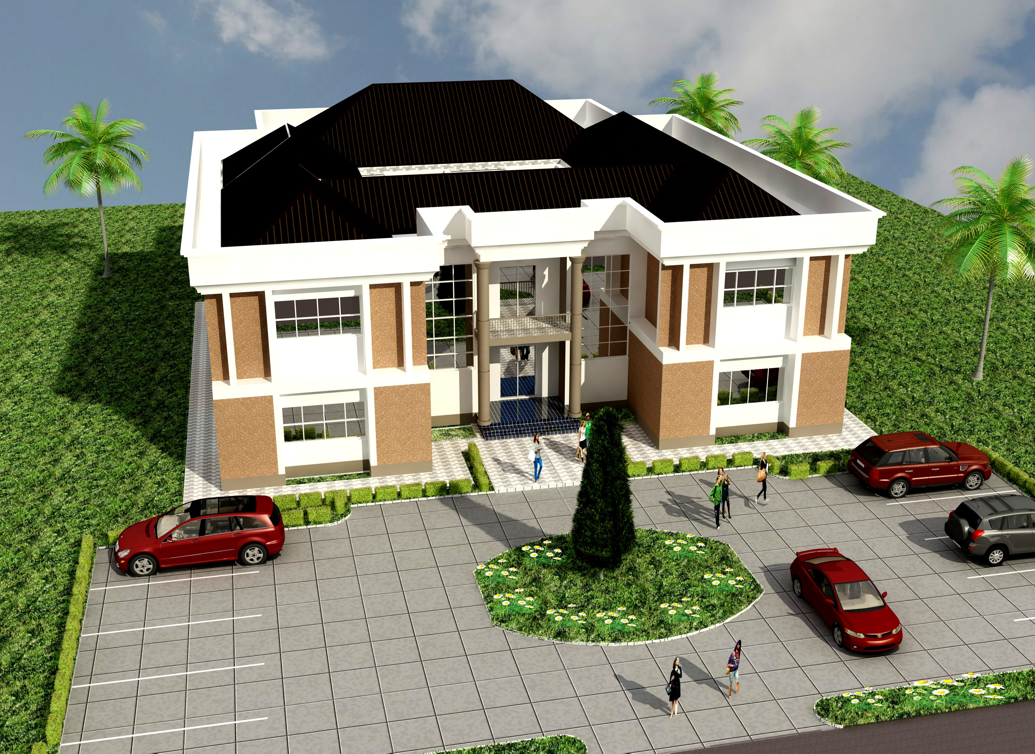

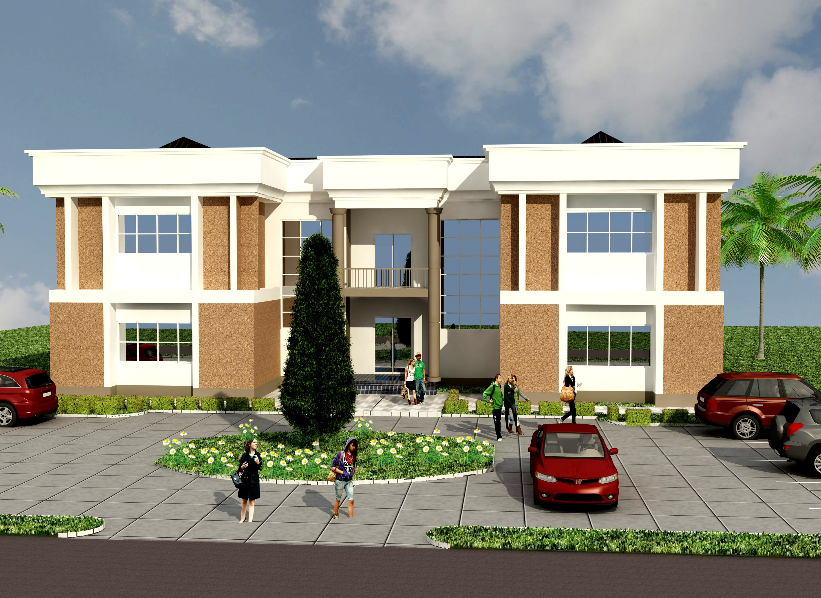

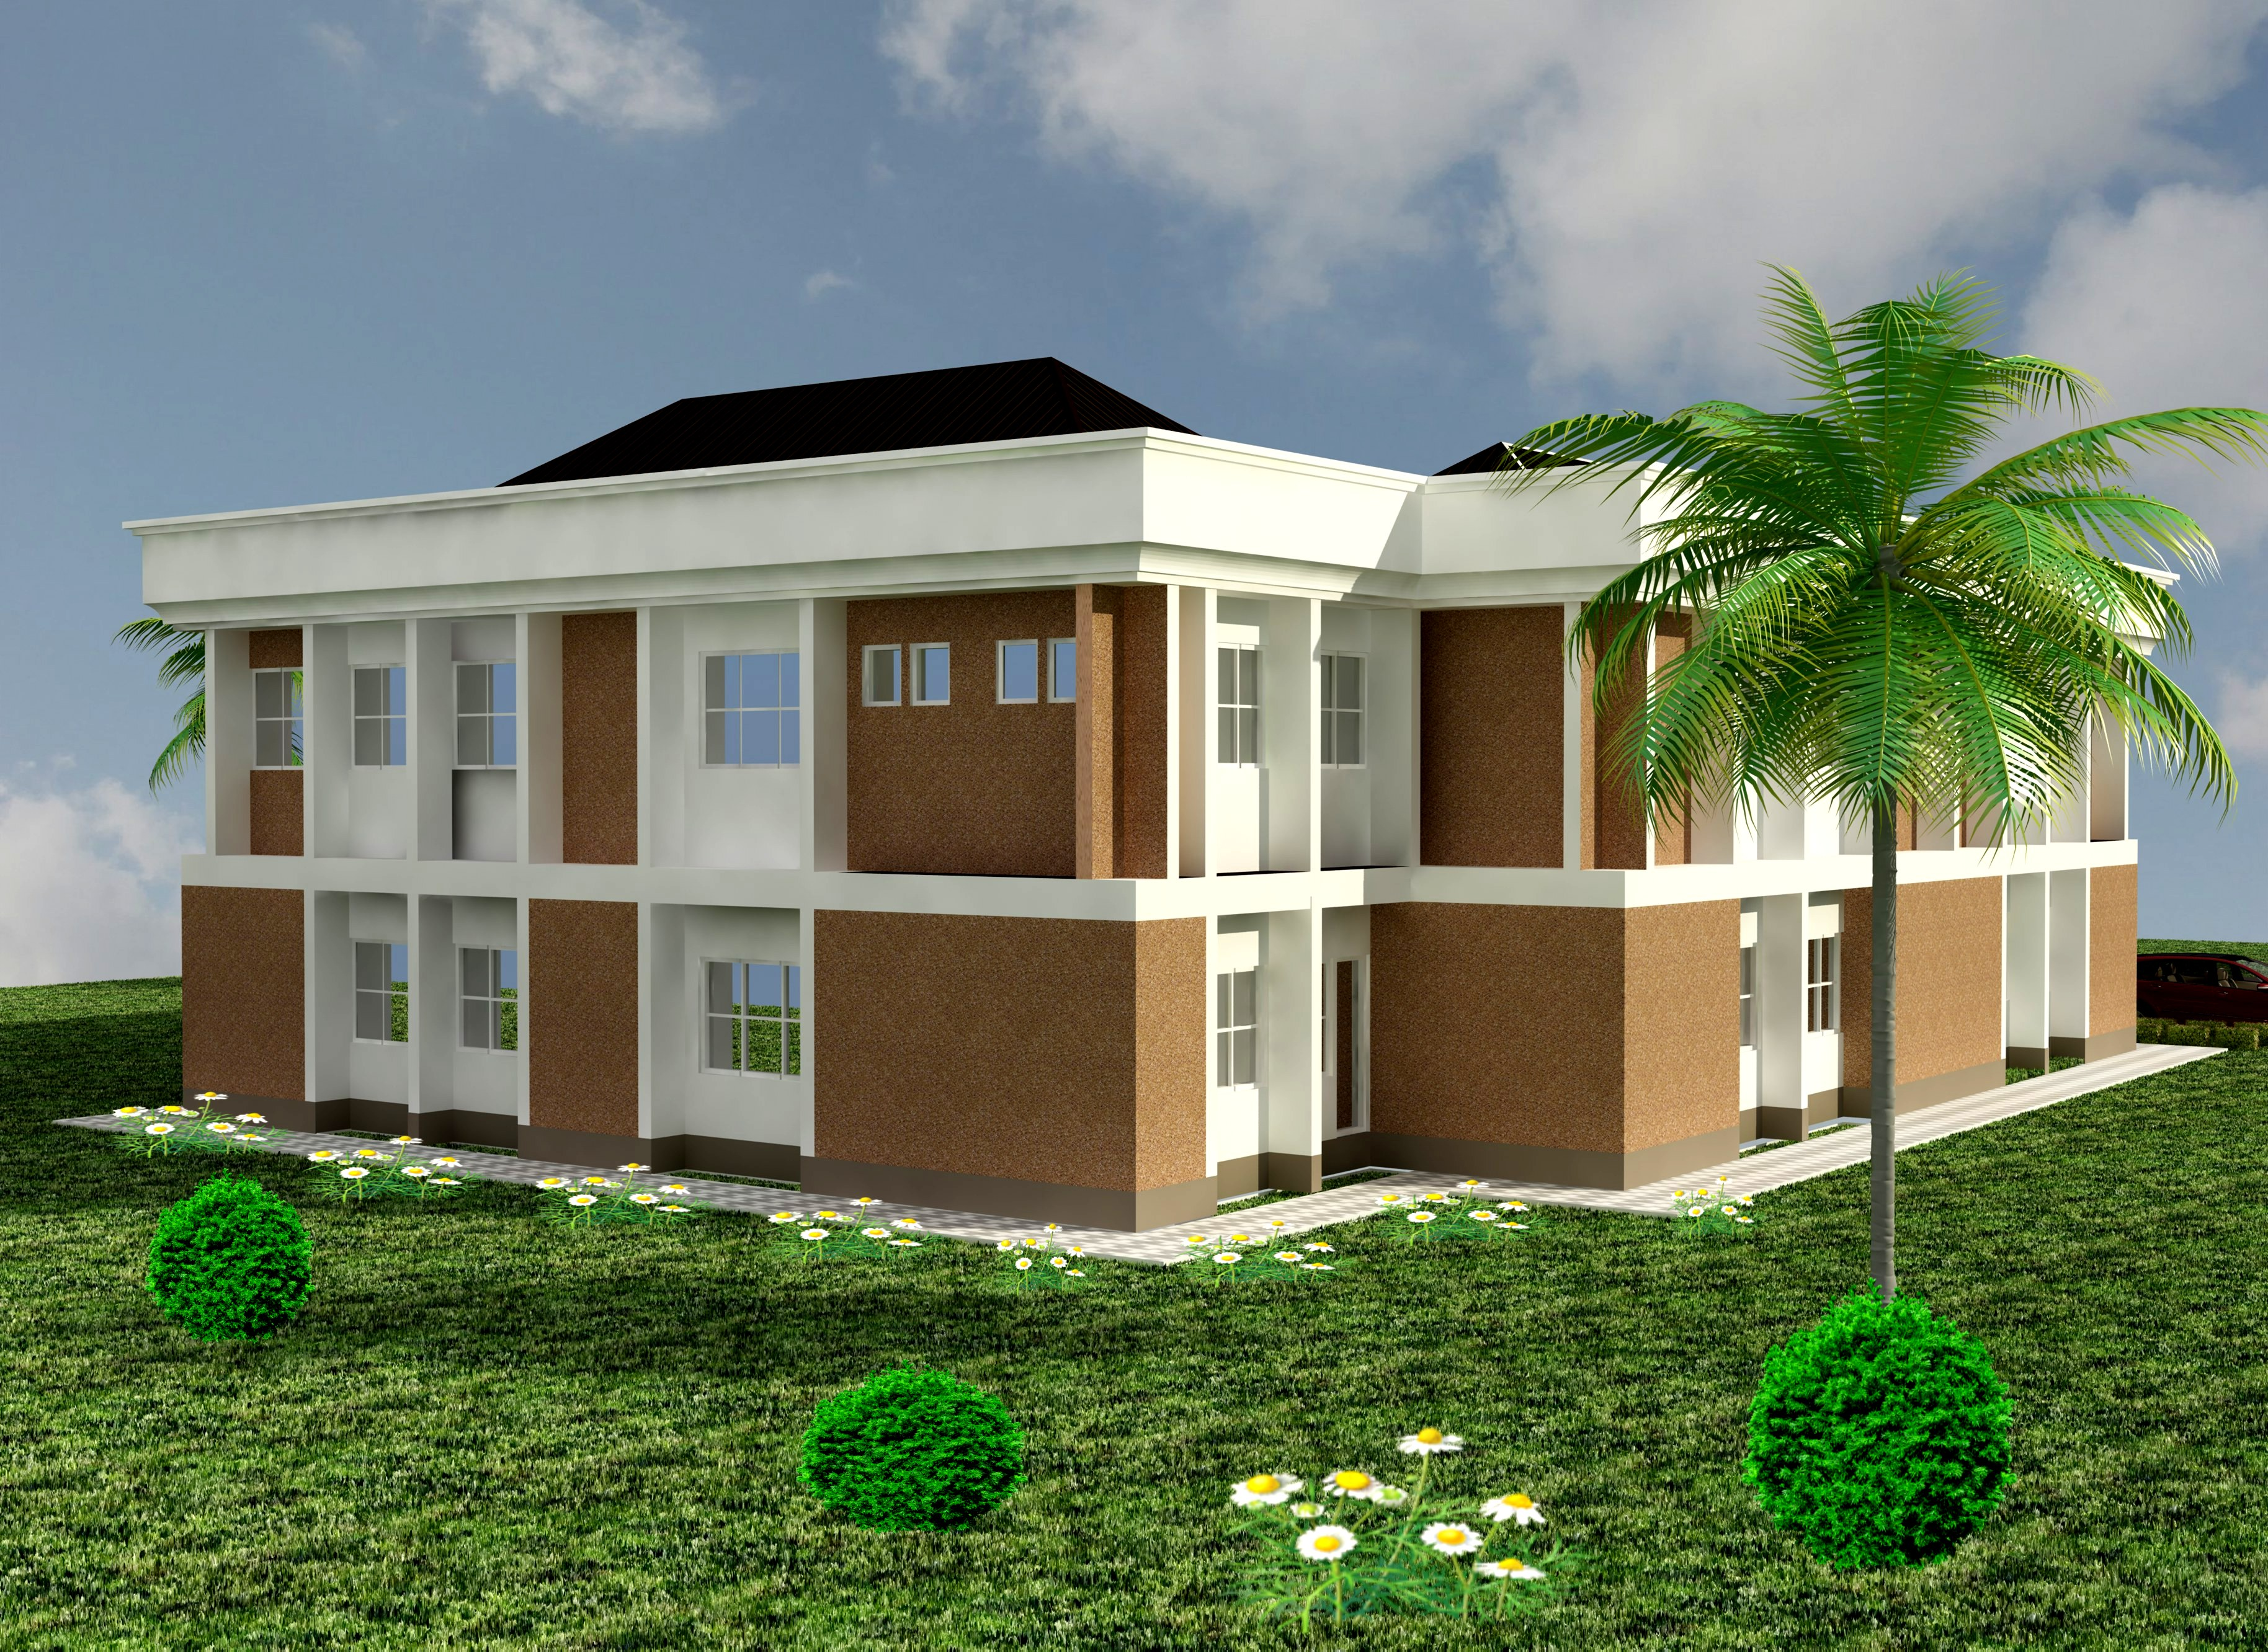

SECTION V **COMPANY’S AUDITTED ACCOUNT/FINANCIAL CAPABILTY**

2016 Auditted Account

2015 Auditted Account

Letter From Skye Bank

**AUDITED ACCOUNT 2016**

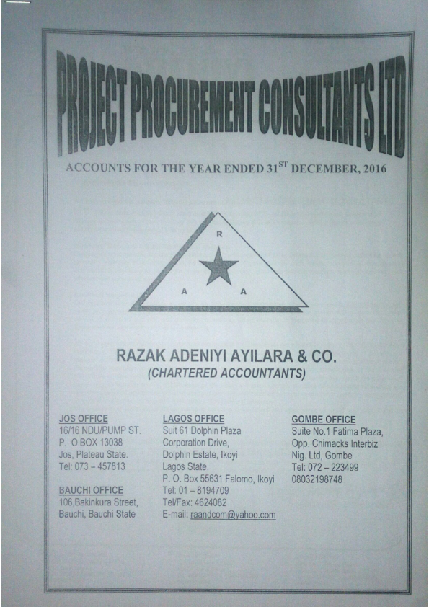

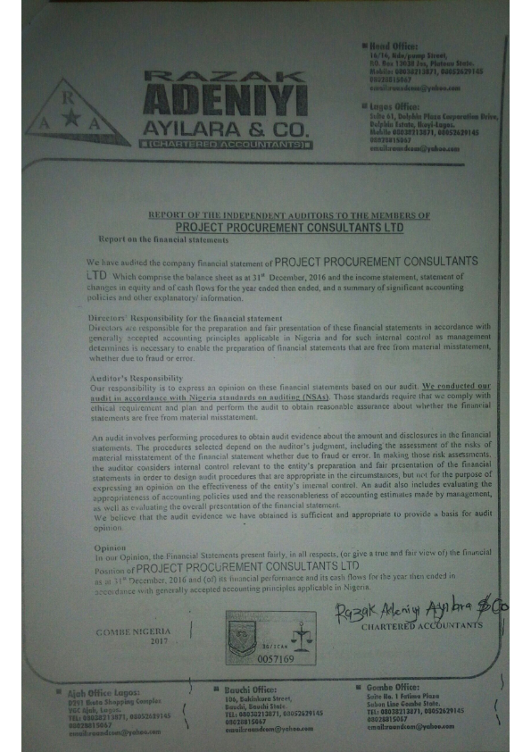

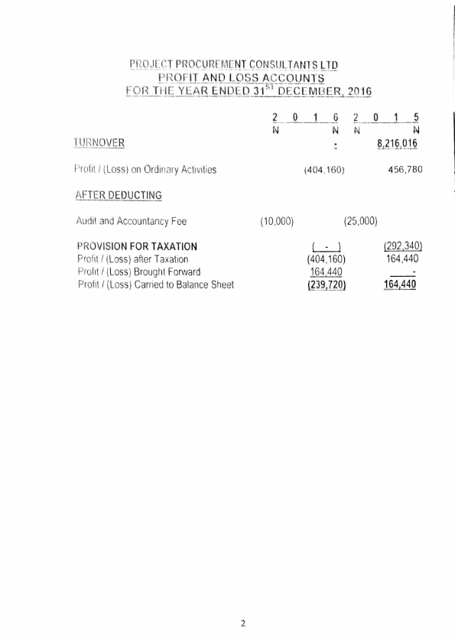

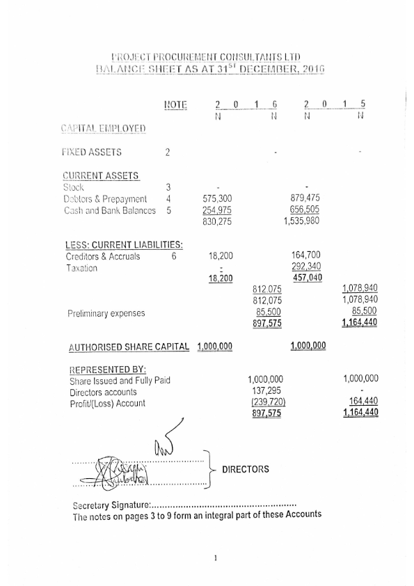

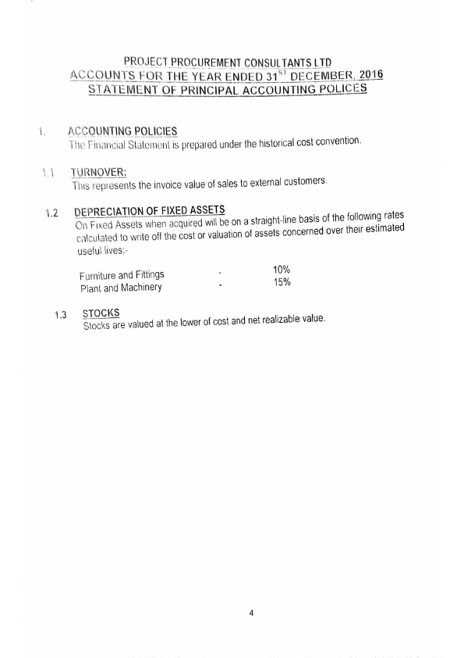

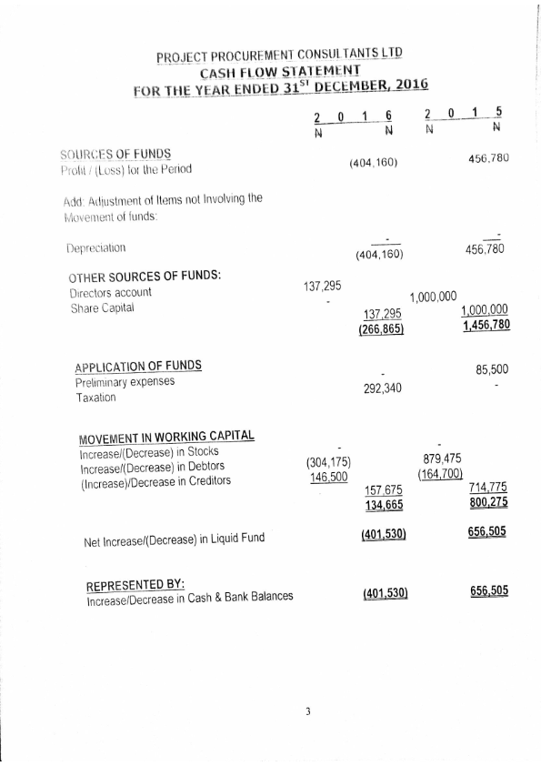

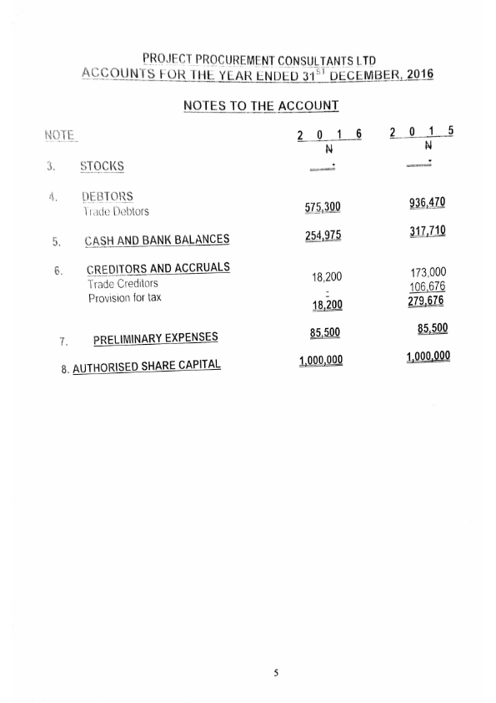

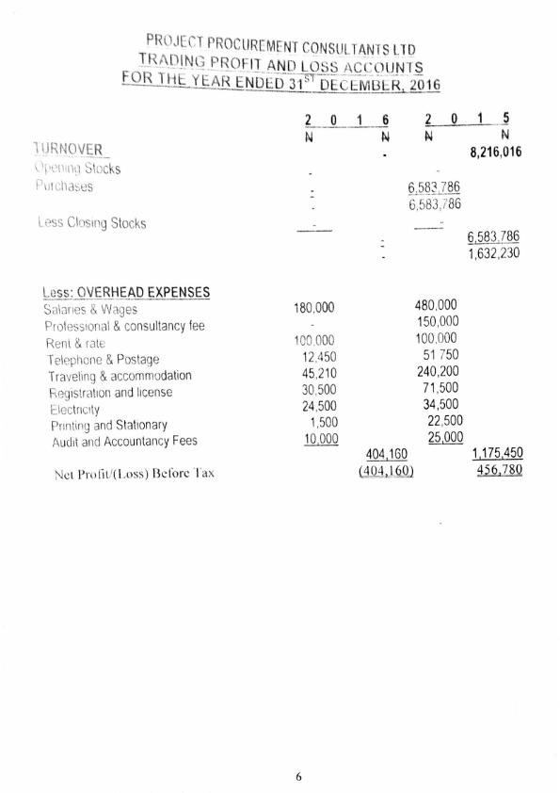

**AUDITED ACCOUNT 2015**

